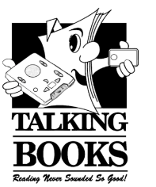
Touch and Listen
The Newsletter of the Florida Braille and Talking Book Library

Summer 2019

News You Can Use

Hurricane Season: What’s in store for 2019?

The National Oceanic and Atmospheric Administration’s (NOAA) Climate Prediction Center is predicting that a near-normal Atlantic hurricane season is most likely this year. Their predictions include a 40% chance of a near-normal season, a 30% chance of an above-normal season and a 30% chance of a below-normal season. The hurricane season officially extends from June 1 to November 30.

For 2019, NOAA forecasts a likely range of nine to 15 named storms, of which four to eight could become hurricanes, including two to four major hurricanes. NOAA provides these ranges with a 70% confidence.

Named storms have winds of 39 mph or higher. Hurricanes have winds of 74 mph or higher. Major hurricanes are category three, four, or five; with winds of 111 mph or higher.

Building Your Disaster Supply Kit
A disaster supply kit should have the basic emergency supply items you and your family will probably need during and after a disaster. Consider the following items when making your disaster supply kit:

- Water – at least one gallon of water per day per person for 3 to 7 days (for both drinking and sanitation);
- Food – 3 to 7 days of non-perishable, packaged or canned foods. Include foods and beverages for infants, elders, and those on special diets;
- A non-electric can opener, paper plates, plastic cups, plastic utensils, garbage bags with plastic ties, kitchen accessories and cooking utensils;
- A portable, battery-powered radio or hand-crank radio, and extra batteries, so you can receive important news, weather reports and instructions from local authorities;
- A first-aid kit; and
- Special needs items such as prescription medications, etc.

A Special Note for Service Animals
If you have a guide dog or other service animal, please think about them during your emergency preparation too! Packing food, water, and even toys for your service animal will help them “weather the storm” better. It may help to inform your planned evacuation shelter that you have a service animal. Remember that your service animal is in-tune with you and your feelings (and chances are you are also very close to them as well); planning for an emergency and knowing you are prepared will help both of you to stay calm should a hurricane or other natural disaster situation arise.

Additional Hurricane Preparedness Resources
The ready.gov website suggests also preparing your home for a hurricane. We recommend reviewing their information on how to secure your property. For additional information on how to prepare for emergencies, check out:
- Ready.gov found at https://www.ready.gov/hurricanes
- Hurricane Safety Tips for the Blind found at https://brailleworks.com/hurricane-safety-tips-for-the-blind/

If you are ordered to evacuate…
Never ignore an evacuation order! Authorities will most likely direct you to leave if you are in a low-lying area or within the greatest potential path of the storm. Be aware that most shelters and some hotels do not accept pets. If a hurricane warning is issued for your area or you are directed by authorities to evacuate the area:
• Take only essential items with you.
• If you have time, turn off the gas, electricity, and water.
• Disconnect appliances to reduce the likelihood of electrical shock when power is restored.
• Make sure your driver’s automobile’s emergency kit is ready.
• Follow the designated evacuation routes.

If you are NOT ordered to evacuate…
The vast majority of injuries during a hurricane are cuts caused by flying glass or other debris. Other injuries include puncture wounds resulting from exposed nails, metal, or glass, and bone fractures. To get through the storm in the safest possible manner:
• Monitor the radio or television for weather conditions.
• Stay indoors until the authorities declare the storm is over.
• Do not go outside even if the weather appears to have calmed – the calm “eye” of the storm can pass quickly, leaving you outside when strong winds resume.
• Stay away from all windows and exterior doors and seek shelter in a bathroom or basement. Bathtubs can provide some shelter if you cover yourself with plywood or other materials.
• Prepare to evacuate to a shelter or to a neighbor’s home if your home is damaged or if you are instructed to do so by emergency personnel.

Summer Reading: Cosmic Books for all ages!
Parents, help prevent “summer slide” and encourage your student to read this summer so they can start their next school year off strong! Kids and teens, we have the absolute best books for you to read – they were selected by other kids and teens just like you! Adults, don’t think just because you aren’t in school that you have to sit out on the fun… we have a book list for you too!

You’re not limited to our lists either. You may record and submit books you read on your own to the library as well. The library’s lists are just to get you started. The most important thing is to read as many books as you can this summer!

To look at this summer’s reading lists, go to the Summer Reading 2019 link on the Library’s website (it’s located on the menu on the left hand side).

We are also posting book reviews of some of the Sunshine State Award Winners and Florida Teens Read winners for 2019-2020 in The Reading Room. (You can also find that on the left-side menu of our website.)

Our summer reading program runs from June 10th to August 9th and it’s entirely online. You can submit book reviews, check for challenges with incentives and prizes, and more! To register, send an email to reading@dbs.fldoe.org with the name of the person reading for the challenge. Then, start reading and we’ll keep in touch!

Tips and Tricks: Books You Can’t Read
Has the following ever happened to you? You’ve been waiting and waiting for a book and it finally arrives so you decide to stop reading the book you started the night before so you can start the long-awaited arrival. You put the cartridge in your player, press play, and you hear… “End of book!” You know you haven’t read the book so what do you do now? How do you resolve the issue so you can enjoy your new treasure?
Sadly, you might not be able to fix it. We do NOT recommend a reset of your player as resetting deletes ALL of the player’s memory (including what you have previously listened to and any bookmarks you may have set). A better choice is to clear the errors on your machine by following these instructions:

To Clear Machine Errors
Press and hold down each of the following 4 player buttons simultaneously for 3-5 seconds:
SLEEP
TONE UP
REWIND
POWER (Press last)

Your machine will beep and announce OK or an error for each of the following 5 items:
PLAYER STATUS
CARTRIDGE
ASSISTIVE TECHNOLOGY
POWER
SYSTEM

IF each one is OK
Press the power button and your machine will turn off.

IF any of them has an ERROR
Press and HOLD the sleep button until your machine turns off. Alternatively, you can press SLEEP as soon as you hear an error.

Try listening to your book again. If clearing the errors did not work, then it means the file on the cartridge has become corrupted. If this happens, call your reader advisor to request another copy and return the defective one to us. In order to notify us that the cartridge is defective, please put a rubber band around the cartridge or a note inside to alert us so we will not send the defective cartridge to another patron.

Need Help with the Library’s Book Service?
Not getting the books you like? Not getting enough? Getting too many? Have you changed your address or phone number?

If you ever feel like you are not receiving all of your books, there are several reasons this might happen:

• You have caught up with all the books written by your favorite authors.
• You are set up as "request only" but have not given us new titles to add to your account.
• You are at your book limit and need to return some items.
• Your desired preferences are too limiting.

Call us at 1-800-226-6075 and let us help you get what you want!

NLS Visits Daytona Beach

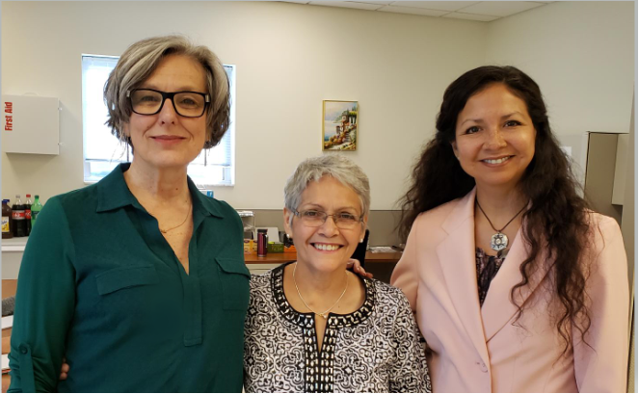
(From left to right) National Library Service Studio Director Celeste Lawson, Florida Studio Coordinator Brunilda Lopez-Soto, Librarian/Production Supervisor Maureen Dorosinski.

National Library Service for the Blind and Physically Handicapped (NLS) Studio Director Celeste Lawson came to Daytona Beach and conducted a training workshop on May 14th and 15th for volunteers and staff of the Library. She explored the three primary production duties of an audio book recording, which are narrator, monitor, and reviewer. Having held each of those roles during her tenure with the NLS, which began in 1991 after a career that included actor, server, would-be economist, and voice-over artist, she has a uniquely qualified perspective. Many tips were shared regarding the recording process and it was truly an enjoyable and informative time.

Narrators had a chance to put some of Celeste’s suggestions into practice after she gave them. For example, she suggested narrators think of someone that they might be reading to/for during the recording process and that narrators would benefit from reading ahead (previewing the material). After applying some of her suggestions and with further feedback from Celeste, the narrators’ inflections became better and the reading more relaxed the second time reading. Other suggestions included having narrators and studio staff holding pillows against their stomachs to muffle gurgling sounds after lunch and keeping feet planted while seated to help ensure one’s voice is the same when making corrections. Even pulling one’s shoulder blades back will give them a little puff of air, which is mainly needed at the end of a sentence.

Everyone thoroughly enjoyed the sessions and we’re looking forward to the improvements in our local productions! We hope that you’ll enjoy some of our new recordings soon!

Fresh from the Recording Studio: New Books

Medical Medium: Thyroid Healing by Anthony William FDB03940
An alternative look at thyroid illness, explaining sources of the problem, providing reasons for inflammation, and detailing ways to recover. Narrator: Gayle Sunderland. Reading time 10 hrs. 55 min.

Palmetto Country by Stetson Kennedy DBC08188
Between 1937 and 1942, Stetson Kennedy crisscrossed the state with a sound recorder the size of a large coffee table to capture the songs, tales, and anecdotes of the pogey fishermen, railroad gandy-dancers, Latin cigar makers, Greek spongers, and the turpentiners. Narrators: Wanda Currie and Pam Masters. Reading time 11 hrs. 15 min.

Theodore Boone: Joven Abogado by John Grisham DBC12751
Thirteen-year-old Theodore Boone knows more about the law than most lawyers do. However, when a high profile murder trial comes to his small town, Boone finds himself in court much sooner than expected and is determined to see that justice prevails. Spanish language. Narrator: Brunilda Lopez Soto. Reading time 7 hrs. 5 min.

Frogkisser by Garth Nix DBC12771
Princess Anya teams with a librarian and her Royal Dogs to help defeat her evil step-stepfather, Duke Rikard, who wants to rule the kingdom and has the power to change people into frogs. Narrator: Sue Christenson. Reading time 12 hours.

Restart by Gordon Korman DBC12770
A bully must come to terms with who he was and what kind of person he wants to be after suffering memory loss from falling off a roof and losing consciousness. Narrator: Susie Baldwin. Reading time 7 hours 45 min.

Mumford the Manatee by Dee Mountcastle DBC12782
A curious baby manatee wandering from his mother encounters a child having an adventure on the river in his boat. Narrator: Pam Masters. Reading time 11 min.

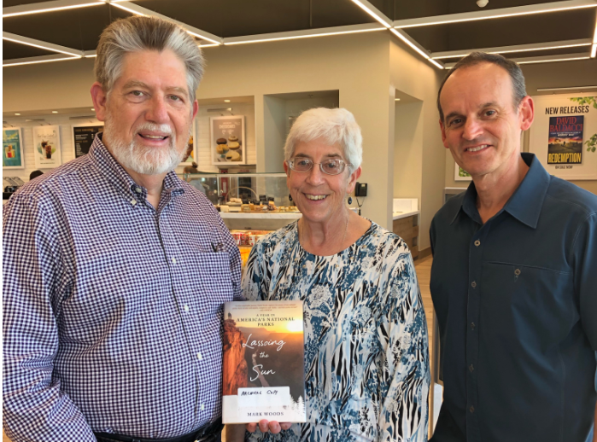
Author of Lassoing the Sun, DBC12749, Mark Woods (right) poses with studio volunteers Tom Hart (left) and Terry Fiset (middle)

Book Reviews

Hello all, hope you all are doing well! It’s Maureen, your librarian, to recommend some books that kept me so engaged that I didn’t want to put them down. I was able to download each of these from BARD, but if you aren’t able to yet, please call us at 1-800-226-6075 and we will make you a cartridge. There are more book reviews posted on the website under the Reading Room menu item.

Books You Just Can’t Stop Reading

The Shakespeare Requirement by Julie Schumacher DB 92244
Now is the fall of his discontent, as Jason Fitger, newly appointed chair of the English Department of Payne University, takes arms against a sea of troubles, personal and institutional. His ex-wife is sleeping with the dean who must approve whatever modest initiatives he undertakes. The fearsome department secretary Fran clearly runs the show (when not taking in rescue parrots and dogs) and holds plenty of secrets she's not sharing. The lavishly funded Econ Department keeps siphoning off English's meager resources and has taken aim at its remaining office space. And Fitger's attempt to get a moss backed and antediluvian Shakespeare scholar to retire backfires spectacularly when the press concludes that the Bard is being kicked to the curricular curb.

It says it is the second in the series, but it works wonderfully as a stand-alone novel. I wasn’t lost nor did I feel as if I was missing anything by starting here. Considering that the first book was mostly letters the protagonist wrote, you really miss nothing if you skip the first one.

If you love young adult books full of romance, danger, and magic, you will love the Age of Legends Trilogy. It is exciting, world-building, and full of characters you will love one minute, loathe the next, and be heartbroken for in the end. Get your mythological creature fix with a good dose of mystery. The books in the trilogy include Sea of Shadows DB 78699, Empire of Night DB 81573, and Forest of Ruin DB 92865.

Sea of Shadows by Kelley Armstrong DB 78699
In the Forest of the Dead, where the empire’s worst criminals are exiled, twin sisters Moria and Ashyn are charged with a dangerous task. For they are the Keeper and the Seeker, and each year they must quiet the enraged souls of the damned. Only this year, the souls will not be quieted.

Empire of Night by Kelley Armstrong DB 81573

Forest of Ruin by Kelley Armstrong DB 92865

Here are some additional awesome and suspenseful psychological fiction titles I came across on BARD:

Behind Closed Doors by B.A. Parks DB85265

Say Nothing by Brad Parks DB91047

Lies by T.M. Logan DB92455

I listened to Behind Closed Doors while walking and running, and I have to say I was so absolutely mesmerized by the plot and development of this story, I ended up going much farther than I expected each time I went out! We listened to Say Nothing in the car on a trip to Michigan and I didn’t drop off sleeping as I usually do on car trips. Have you ever gotten so wrapped up and invested in a story that you started yelling at the main characters? That is exactly what happened to my husband on the same trip with Lies.

Happy Reading!

-Maureen

