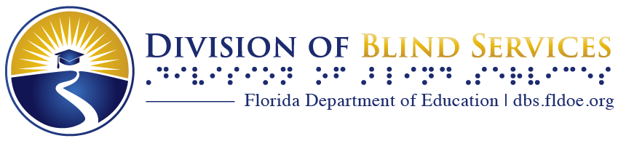

Touch and Listen
The Newsletter of the Florida Braille and Talking Book Library

Summer 2023

What’s Happening in Florida

New Bureau Chief
After 7 years at the Braille and Talking Book library, and over 30 years with the Division of Blind Services, Bureau Chief James Woolyhand retired last year. We thank him for all he has contributed and wish him all the best.
The Division of Blind Services is happy to introduce our newest Librarian and head of Library Services:
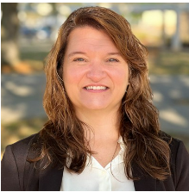
“Hello! My name is Nicole Sanders, and I am the new Bureau Chief of the Braille and Talking Book Library. I am a native Floridian, but I just moved back to Florida last summer after being in Texas for 20 years. I am thrilled to be “home.” I earned my bachelor's degree in education and my master’s degree in library science from Texas Woman’s University. I served as an educator and public-school librarian before returning to Florida.
I am excited about serving the patrons of the library and working with the wonderful staff and volunteers.”

Commissioner Manny Diaz, Jr. Announces June Books of the Month
Florida Commissioner of Education Manny Diaz, Jr. announced June’s chosen books for the Commissioner’s Book of the Month, a monthly reading challenge to promote literacy and reading engagement in preK-12 schools.
“This month’s selections celebrate inspirational stories of individuals who overcame adversity and provide families a variety of books to enjoy together.”
Available in our collection:
- Grades K-2 – Harlem Grown: How One Big Idea Transformed a Neighborhood by Tony Hillery BR 23748 (braille) plus BARD
- Grades 6-8 – The Hiding Place by Corrie ten Boom
BR 02785 and DB 43746
- Grades 9-12 – The Piano Lesson by August Wilson
BR 08832 and DB 34104

All Ages Summer Reading Spotlight
We have an exciting way to keep track of your books and earn fantastic incentives this summer!
The Summer Reading Spotlight will run from Monday, June 26 through Friday, August 4, 2023.
Everyone who registers is entered. Try to read as many books as you can. Top readers can earn an incentive including tote bags, water bottles, or other fun items! A special bonus: we count the books for you! NO other action is needed.
To register:
- Email your name or your child’s name, age, and patron number to reading@dbs.fldoe.org.
- Start reading! Any book you like will count. Try themes like the ocean, summer, gardening, baseball, the outdoors, or try new recipes in a cookbook!
- For extra fun, try a weekly Summer Activity from our Summer Reading page on our website dbs.fldoe.org/library and let us know how you like it!
Stay connected through reading@dbs.fldoe.org!

New Feature: Patron Stories
If you have a story you would like to share about how our services have benefitted you or someone you know, please email us at reading@dbs.fldoe.org.

NFB-NEWSLINE®
NFB-Newsline® is a free audio news service for anyone who is blind, low-vision, deafblind, or otherwise print-disabled that offers access to more than 500 publications, emergency weather alerts, job listings, and more. NFB-Newsline® offers 16 newspapers for Florida, some of which include:
- Daytona Beach News Journal
- Florida Times Union
- Miami Herald
- Orlando Sentinel
- Tampa Bay Times
- Treasure Coast Newspapers
Want to learn more about what else they offer?
Contact the library that serves your account and sign up. It’s easy and the newspapers and magazines can be played on your phone, iPhone, iPod or iPad, or your Amazon Alexa device. You may also listen through the NFB-Newsline® website or have content sent to your email.

National Library Service (NLS) Corner

New NLS Magazines
NLS has expanded and enhanced the variety of its magazine content by adding 21 new magazines, such as:
- Bookmarks
- Cooking Light
- Dogster
- International Living Magazine
- Jet
- Prevention Magazine

Call your reader advisor to find out more and subscribe. Use BARD to download any issues whenever you want!
Keep up with all the latest news from NLS by visiting the Announcements and Notices page on our website dbs.fldoe.org/library.

The Reading Room

Booklists of the Moment:
Twisty Books are books with unexpected plot twists and suspenseful storylines to keep you intrigued. These are books many people say they did not want to put down!
We offer new booklists each quarter and post them on The Reading Room section of our website at dbs.fldoe.org/Library/Reading.
There’s some great Twisty Books up there now! Here is one:
DB 91636 The Last Mrs. Parrish by Lynne Constantine and Valerie Constantine
Amber Patterson is tired of being a nobody. She deserves more--a life of money and power like the one socialite and philanthropist Daphne Parrish takes for granted. Amber's plan to insinuate herself into Daphne's life works wonderfully--until a skeleton from her past threatens everything. Commercial audiobook. 2018. Adult level.

We also have a Seasonal Favorites section which includes themes such as Spring Cleaning and Organization, Gardening, and Baseball.

New Subject Headings:
We have added more subject headings to our catalog, as a way for you to have even better control over your book selections! Contact your library and ask to have these subjects added to your account. If you have auto selection, the system will be better able to match you with more of the titles you want!
- Christian Fiction
- Action
- Time Travel
- Romance - Homecoming
- Romance - Military or Veterans
- Historical Fiction - Military
- Historical Fiction - WW2
- Historical Fiction - Vietnam War

Duplication on Demand
We have made great progress on our transition to Duplication on Demand (DOD). Previously, we filled your requests from a large collection of permanent cartridges, each one containing a single title. With DOD, multiple titles are downloaded from BARD onto one cartridge created just for you and then erased and reused upon return.

No work is needed on your part to use DOD! The system uses your existing preference settings and requests, which increases access to the wide range of older and newer titles available in our collection and provides less waiting time for new books to arrive on cartridge.

How it works
Each week you will receive a cartridge with 5 or more Talking Books on it for you to enjoy. When you have in your possession 5 cartridges, we will stop sending further cartridges until you return a cartridge for us to load up your next set of books. Returning your Talking Book cartridges is always free by flipping over the mailing card on the shipping container.

You will receive books according to the choices you make by selecting subjects, authors and titles. You may go to flopac.klas.com, our Online Public Access Catalogue where all titles in our collection are listed and make selections to be added to your account.

Contact the library servicing your account for assistance with updating information on your account, adjusting the number of books you wish to receive on a Duplication on Demand cartridge, and other library services.

The more books you have on your request list and the more subjects you have added to your account, the better. We are eager to bring you more books, faster and more conveniently than ever!

Fresh from the Florida Recording Studio

Magazine Anthologies
We offer great anthologies, created from our locally produced magazines and newsletters, combined with magazines available from BARD. Depending on the collection, they can be produced from 2 to 4 times each year. There are multiple monthly issues of each title included in each collection.

Here is one of the six collections:
Literary, Culture, History: March, Sept.
- Current Biography- produced in Florida!
- Ebony- new from NLS
- American Indian – new from NLS
- Reflections from Central Florida- produced in Florida
- Travel + Leisure
- Magnets and Ladders
- Smithsonian
- Poetry- produced in Florida

The Bureau of Braille and Talking Book Library Services are part of the
Florida Department of Education, Division of Blind Services.
Visit our websites at www.dbs.fldoe.org or www.fldoe.org

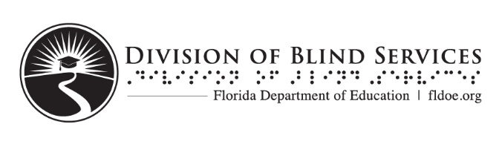
Contact us at 1-800-226-6075 or via email at OPAC_librarian@dbs.fldoe.org

