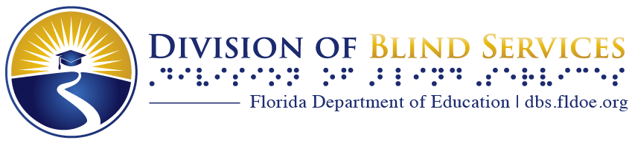

Touch and Listen
The Newsletter of the Florida Braille and Talking Book Library

Winter 2024-25

What’s Happening in Florida

From the Bureau Chief, Nicole Sanders
Here we are finishing off another year. It has been busy here at the library as we clean out, organize, and refresh the library for another fun year. We are excited to kick off 2025 and see what the year has in store for us.
As the cold fronts continue, snuggle up with a good book and enjoy a cozy mystery or two. I hope you enjoy the season with some fantastic reading. Also, check out our programs and engage with other patrons.

Thank you and happy reading!

Calling the Regional Library, Daytona Beach
Based on direct feedback from you, our patrons, we are changing the way we handle calls to Reader Services. Starting February 3, 2025, calls will be handled live and a reader advisor will be standing by to answer your questions. This change allows us to answer your calls more immediately and reduce the need to leave a message. This may also mean that you will have the pleasure of working with all our skilled reader advisors instead of just one! Please be patient as we train to give you the very best service and make this transition.

Programming at your Florida Braille and Talking Book Library

Reading Challenge: Winter Warm Up
Take this opportunity to read something challenging!
- Read The Winter’s Tale by William Shakespeare.
- Or play it safe and read a cozy mystery.
When complete, email reading@dbs.fldoe.org with “WINTER” in the subject line, your name and the title of the book you read to claim your prize!
The challenge runs from now until the end of March.

The Community Table: a recipe collection that is truly yours
We invite you to reminisce about beloved family homemade meals and treats. Do you have a cherished recipe you’d like to share? We are gathering them for “The Community Table,” a unique collection that will be produced in audio, braille, and (eventually) large print.
- To contribute, please email your recipe along with a brief paragraph explaining why it’s special, to reading@dbs.fldoe.org.
Thank you for helping us create something truly wonderful to share!

Calling All Cooks Monthly Meetup
A group for those who have been cooking practically since birth and those who are just getting started! Meet challenges and find support with other blind or low vision cooks as they navigate from hunger to fulfillment.
The Fourth Friday of every month at 2- 3 pm Eastern time.
- Next Meetings: January 24, February 28, March 28
Email your name to reading@dbs.fldoe.org to sign up, with “COOK” in the subject line to get the call in number and conference ID or the Teams meeting link.

Wrangling All Writers Monthly Meetup
A group for writers to share and practice the fun of flash fiction, very short stories of 250-1,500 words. Take part in writing prompts and story challenges.
The last Wednesday of every month, 10-11 am Eastern time.
- Next Meetings: January 29, February 26, March 26.
Email your name to reading@dbs.fldoe.org to sign up, with “WRITE” in the subject line to get the call in number and conference ID or the Teams meeting link.

National Library Service for the Blind and Print Disabled (NLS) Corner

Braille On Demand
Braille on Demand allows NLS patrons to request hard copies of braille books currently on BARD that they would like to read on paper. NLS allows a maximum of 5 books per month and estimates books will be delivered in 3-4 weeks.

NLS Braille on Demand Request Form

The Reading Room

Large Print Item: Selections from Talking Book Topics
Selections from Talking Book Topics is the Library’s catalog of condensed listings from the larger Talking Book Topics published by the National Library Service for the Blind and Print Disabled, Library of Congress. They are published every two months, and should be available by the middle of the month when they are released. For example, November/December was made available by the middle of November.
Each edition includes at least 5 books from popular genres, determined by the majority of our library patron's preferences. We have created fiction and non-fiction versions.
The Fiction version includes:
- Mystery & Detective, Romance, Historical Fiction, Suspense & Thrillers and Westerns.
The Non-fiction version includes:
- Biography, U.S. History, World History, Religion and Science.
Contact your local library to subscribe!

The full NLS Talking Book Topics catalog is available online at loc.gov/nls/new-materials/talking-book-topics/ and also as an audiobook.

Holiday Closing Dates
We are open from Monday-Friday from 8 am to 5 pm. Our upcoming holidays:
Wednesday, December 25 Christmas Day
Wednesday, January 1 New Year’s Day
Monday, January 20 Dr. Martin Luther King Jr.’s Birthday (observed)

The Bureau of Braille and Talking Book Library Services are part of the
Florida Department of Education, Division of Blind Services.
Visit our websites at www.dbs.fldoe.org or www.fldoe.org

Contact us at 1-800-226-6075 or via email at OPAC_librarian@dbs.fldoe.org
