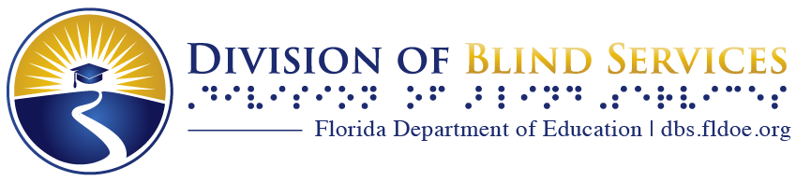

Touch and Listen
The Newsletter of the Florida Braille and Talking Book Library
Spring 2025

What’s Happening in Florida

From the Bureau Chief, Nicole Sanders

Springtime at the Library: A Season of Renewal!

As the weather warms and nature comes to life, it’s the perfect time to explore everything the library has to offer. Whether you’re in the mood for books about gardening, wildlife or simply a great story to enjoy outdoors, we’ve got you covered! But there’s more than just books—don’t miss our special events, like Container Gardening and Birding by Ear!

Stay up to date with all the latest library news in our newsletter, now available twice a year—in Spring and Fall! Discover new books, read-alike authors, exciting programs and more. Plus, we’re thrilled to offer the newsletter by email! Let a Reader Advisor know if you’d like to subscribe.

Looking for the perfect book for a springtime picnic? Interested in exploring a new genre? Want to try a new library program? We have something for everyone!
Enjoy the season and, as always, happy reading!

Calling the Regional Library, Daytona Beach
Thanks to your feedback, we’ve made important changes to how we handle calls to Reader Services. Now, your calls are answered live by a Reader Advisor, ensuring faster service and reducing the need to leave a message.

This change also means you’ll have the opportunity to work with all of our skilled Reader Advisors instead of just one! As we transition to this improved system, we appreciate your patience (and feedback). We look forward to providing you with the best service possible.

Programming at your Florida Braille and Talking Book Library

NEW! Paws To Read Book Club
- First Thursday of every month at 2-3 pm Eastern time, first meeting May 1.
Pet and animal enthusiasts will enjoy this book club!
Email your name to reading@dbs.fldoe.org to sign up, with “PAWS” in the subject line to get the 12-month book list and add it to your book service queue.
- May 1 DB046030, BR011528 James Herriot's Animal Stories. Author: Herriot, James.
- June 5 DB066656 BR017799 The Story of Edgar Sawtelle. Author: Wroblewski, David.
- July 3 DB069557, BR018591 Homer's Odyssey : A Fearless Feline Tale; or, How I Learned About Love and Life With a Blind Wonder Cat. Author: Cooper, Gwen.
- August 7 DB073300, BR019434 Thunder Dog : The True Story of a Blind Man, His Guide Dog, and the Triumph of Trust at Ground Zero. Author: Hingson, Michael.

Reading Challenge: Spring Into Reading
Take this opportunity to read something seasonal!
- Read three books with the word “spring” in the title or subject.
When complete, email reading@dbs.fldoe.org with “SPRING” in the subject line, your name and the titles of the books you read to claim your prize!
- The challenge runs from now until the end of June.

SPECIAL EVENT CALL IN PROGRAMS
Birding By Ear Spring Edition
Monday, April 21, 10-11 am Eastern time.
The week of April 21, 2025, marks the peak of spring bird migration in Florida! This is the perfect time to listen to bird songs and calls as flocks pass through the state. Tune in and learn how to identify the birds in your area by their sounds—it's a great way to connect with nature this season!
  - Call 1-850-583-5063, Phone conference ID: 411 002 716 #

Container Gardening
Friday, April 25, 1-2 pm Eastern time.
Ever wonder if you can garden with low vision or after losing your vision? Well you can! Container gardening is a particularly easy, fun way. Find out how!

Call 1-850-583-5063, Phone conference ID: 313 357 303 #

Resource Research
Tuesday May 6, 10-11 am Eastern.
Get help finding resources in your area for blindness, accessibility and more.
- Call 1-850-583-5063, Phone conference ID: 315 149 586 #

BARD By the Book
Friday, May 16, 1 pm-2 pm Eastern.
Talking book machine and braille e-reader equipment questions and answers.
- Call 1-850-583-5063, Phone conference ID: 827 803 232 #

RECURRING MONTHLY CALL IN PROGRAMS

Calling All Cooks Monthly Meetup
Whether you're a seasoned cook or just starting out in the kitchen, connect with others to discuss cooking challenges, share recipes and swap helpful tips. It’s a great way to learn, get inspired and enjoy the art of cooking together!
The Fourth Friday of every month at 10-11 am Eastern time.
- Next Meetings: April 25, May 23, June 27, July 25
Email your name to reading@dbs.fldoe.org to sign up, with “COOK” in the subject line to get the call in number and conference ID or the Teams meeting link.

Wrangling All Writers Monthly Meetup
New or lifetime writers, all are welcome for ‘what happens next’ prompts and story challenges. The last Wednesday of every month, 10-11 am Eastern time.
- Next Meetings: April 30, May 28, June 25, July 30
Email your name to reading@dbs.fldoe.org to sign up, with “WRITE” in the subject line to get the call in number and conference ID or the Teams meeting link.

National Library Service for the Blind and Print Disabled (NLS) Corner

Music Service and Materials
The Music Section of the National Library Service for the Blind and Print Disabled (NLS), part of the Library of Congress, has grown into the largest collection of its kind in the world! Originally authorized by Congress in 1962, this incredible resource now offers over 25,000 titles, including braille and large-print scores, as well as recorded instructional materials on music and musicians. You can also explore music-related magazines in both audio and braille.

Whether you're a musician, a music lover or just getting started, this collection has something for everyone!

Any person eligible for NLS service is also eligible for NLS music services. While patrons receive most NLS services through the network of cooperating libraries, NLS music materials circulate directly to patrons from the NLS headquarters in Washington, DC.

All music materials may be received via postage-free mail, and many digital audio and electronic braille (e-braille) materials are available for download via the Braille and Audio Reading Download (BARD) website or mobile app. Musical recordings intended solely for listening pleasure are not included in the music collection, as they are available from public libraries.

How to Request Music Service
Patrons already registered with a cooperating network library should contact the NLS Music Section directly either via phone (1-800-424-8567 ext. 2) or via email (nlsm@loc.gov).

The Reading Room

Large Print Item: Selections from Talking Book Topics
Selections from Talking Book Topics is the library’s catalog of condensed listings from the larger Talking Book Topics published by the NLS. They are published every two months and should be available by the middle of the month when they are released.
Each edition includes at least 5 books from popular genres, determined by the majority of our library patron's preferences. We have created fiction and non-fiction versions.
The Fiction version includes:
- Mystery & Detective, Romance, Historical Fiction, Suspense & Thrillers and Westerns.
The Non-fiction version includes:
- Biography, U.S. History, World History, Religion and Science.
Contact your local library to subscribe!
The full NLS Talking Book Topics catalog is available online at loc.gov/nls/new-materials/talking-book-topics/ and also as an audiobook.

New and Notable Subject Headings
Patrons may use our auto selection service to have books selected for them in subject areas they are interested in. It ensures a steady supply of books on a regular basis.

New Historical Subject Headings:
- African American history
- Asian American history
- Native American history
- Women’s history
- Florida history
New Bestseller Headings:
- Bestseller - Fiction - 2010s
- Bestseller - Fiction - 2020s
- Bestseller – Non Fiction - 2010s
- Bestseller – Non Fiction - 2020s

Other Popular Subject Headings you may enjoy:

- Adventure & adventurers - Nonfiction
- Animal Stories - Fiction
- Humor (fiction)
- Fiction - Mothers and daughters
- Fiction - Domestic
- Fiction – Psychological
- Music & Musicians & Dance fiction
- Mystery & Detective - Cozy Mystery
- Mystery & Detective - Historical Mystery
- Romance suspense fiction
- Recreation - Indoor games
  - Also, Card game instructions, and Puzzles and Word games
- Science fiction - Time travel
- Sea Stories, Mariners, Ocean travels (Nonfiction)
- Suspense fiction
- Fiction - Sea Stories
- Travel & Geography (specific locations also available)
- Sports Fiction (specific sports also available)
- Spy fiction
- Science - Astronomy & space exploration
- Short Stories (Fiction)
- Romance
- Medicine and Health

Running Out of Books by your favorite author?
Here are some popular authors and similar ones you might like. Please note, some authors write more than one type of novel, so remember you can always call your reader advisor for help!
Like Danielle Steel?
Try Barbara Delinsky, Barbara Taylor Bradford, Eileen Goudge, Luanne Rice, Nicholas Evans, Elizabeth Lowell, Elizabeth Adler, Jennifer Blake, Diane Chamberlain, Fern Michaels, Rosamunde Pilcher, Nora Roberts, Nicholas Sparks
Like James Patterson?
Try Michael Connelly, Jeffery Deaver, Patricia Cornwell, Linda Castillo, Greg Iles, John Sandford, Ridley Pearson, Jonathan Kellerman, Harlan Coben, Stephen J. Cannell, Thomas Harris, Dean Koontz, Richard North Patterson, Phillip Margolin, T. Jefferson Parker, Iris Johansen
Like David Baldacci?
Try Stuart Woods, Stephen J. Cannell, Jeffrey Archer, Brad Meltzer
Like John Grisham?
Try David Baldacci, Brad Meltzer, John T. Lescroart, Stuart Woods, Lisa Scottoline, Scott Turow, Steve Martini, Michael Connelly, Nelson DeMille, Richard North Patterson, Ed McBain, Greg Iles
Like Nora Roberts?
Try Sandra Brown, Maeve Binchy, Janet Dailey, Barbara Delinsky, Heather Graham, Tami Hoag, Linda Howard, LaVryle Spencer, Susan Elizabeth Phillips, Judith McNaught, Jayne Ann Krentz, Iris Johansen, Elizabeth Lowell, Kay Hooper, Elizabeth Adler, Suzanne Brockmann, Fern Michaels, Mary Jo Putney, Danielle Steel, Stella Cameron
Like Mary Higgins Clark?
Try Mary Jane Clark, Iris Johansen, James Patterson, Sue Grafton, Maxine Paetro, Stuart Woods, Tami Hoag, Joy Fielding, Karen Harper, Nancy Pickard, Iris Johansen, Gillian Flynn, Lisa Gardner, Carol Higgins Clark, Nora Roberts, J.A. Jance, Faye Kellerman
Like Debbie Macomber?
Try Jennifer Chiaverini, Sandra Dallas, Robyn Carr, Susan Wiggs, Lori Wilde, Sherryl Woods, Lori Copeland, Richard Paul Evans, Jan Karon, Barbara Delinsky, Dorothy Garlock, Susan Mallery, Joan Medlicott, Fern Michaels, Emilie Richards, LaVyrle Spencer, Belva Plain
Like Louis L’Amour?
Try Larry McMurtry, Zane Grey, Loren D. Estleman, Cormac McCarthy, Elmer Kelton, William W. Johnstone, J.A. Johnstone, Richard S. Wheeler, Max Brand, Marcus Galloway, Ralph Cotton, Terry C. Johnston

Coming Soon: The Next-Generation Talking Book Machine!
The DA2 is the latest talking book machine, designed to enhance your reading experience. With built-in Wi-Fi connectivity, it allows you to download books directly from BARD without needing a computer or additional devices. We will announce when our first limited allotment arrives, and priority will be given to patrons who use Wi-Fi. Stay tuned for more details!

Image is of a square, black talking book machine, with a handle on the left side, underneath the speaker. Alongside the handle are buttons for Shelf (square), Mark (diamond), and Mode (Round, yellow).
Three groups of buttons controlling the device include:
Across the top: Tone, Volume (yellow), and Speed.
In the center: 4 directional buttons around an orange button, and a grey Power button.
At the bottom: a green Play button, with arrow for rewind and fast forward on either side, and a Sleep button.
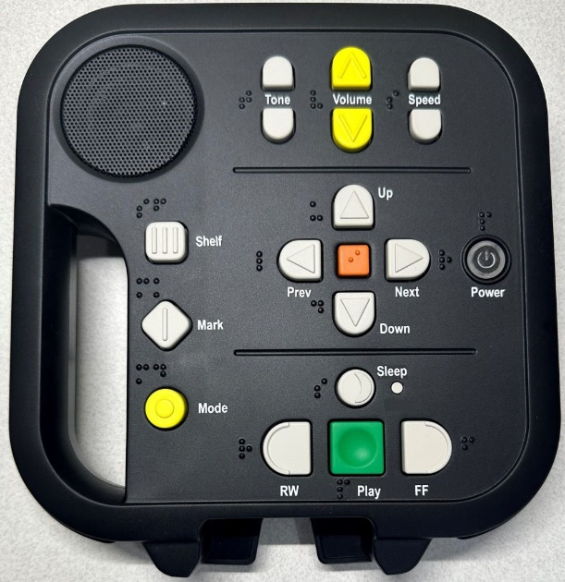

Holiday Closing Dates
We are open Monday-Friday from 8 a.m. to 5 p.m. Eastern time. Our upcoming holidays:
Monday, May 26 Memorial Day
Friday, July 4 Independence Day
Monday, September 1 Labor Day

The Bureau of Braille and Talking Book Library Services are part of the
Florida Department of Education, Division of Blind Services.
Visit our websites at www.dbs.fldoe.org or www.fldoe.org

Contact us at 1-800-226-6075 or via email at OPAC_librarian@dbs.fldoe.org
