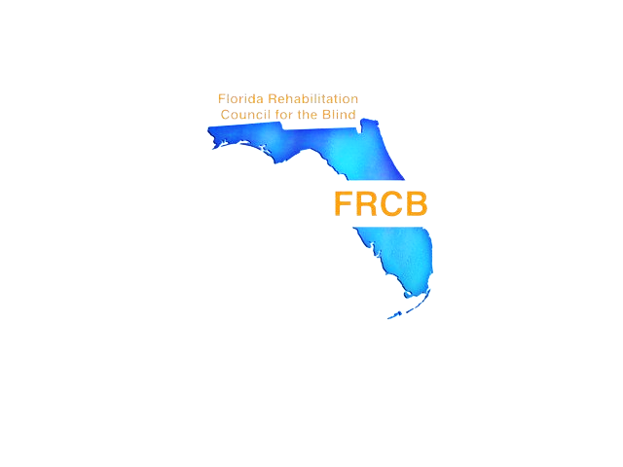

FLORIDA REHABILITATION
COUNCIL FOR THE BLIND
2016 ANNUAL REPORT

DIVISION OF BLIND SERVICES
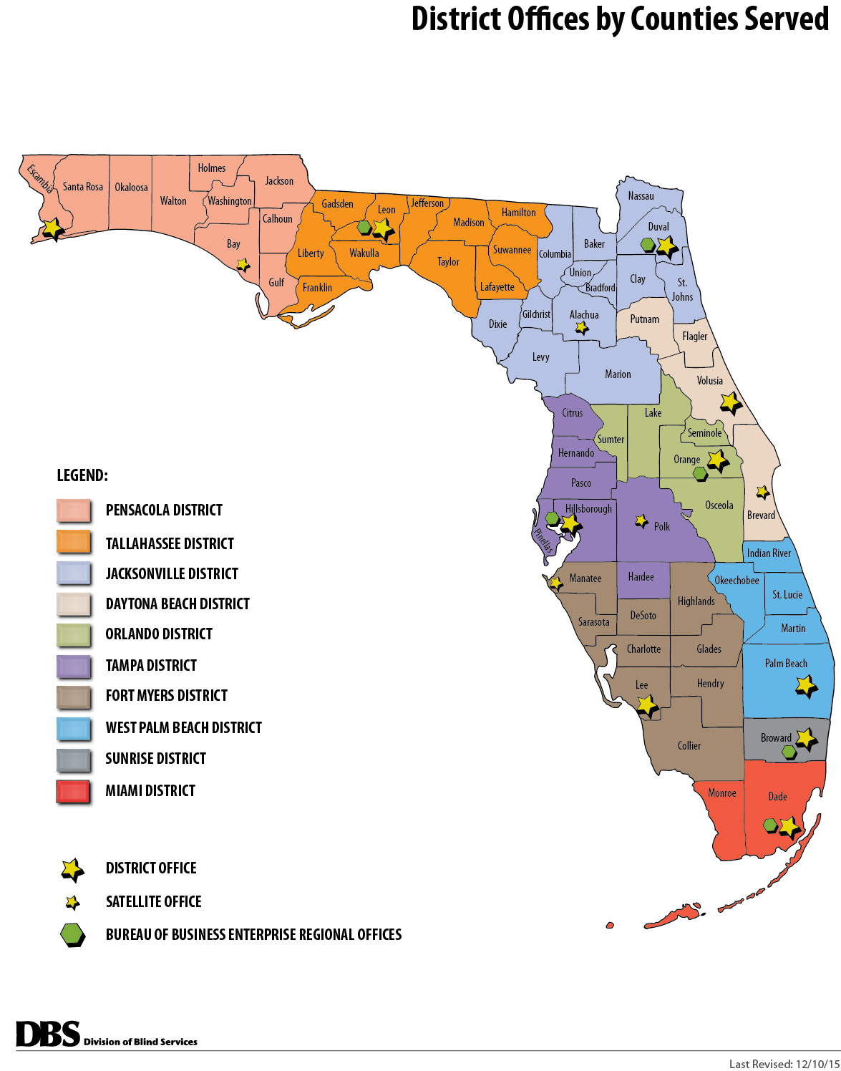
DISTRICT & BUREAU OF BUSINESS ENTERPRISES REGIONAL OFFICES

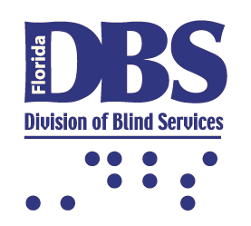

Mission Statement
To ensure blind and visually-impaired Floridians have the tools support and opportunity to achieve success

Florida Rehabilitation Council for the Blind
Mission Statement

The Florida Rehabilitation Council for the Blind reviews, analyzes and advises on the policy decisions and evaluates the effectiveness of the Florida Division of Blind Services to ensure meaningful access to and use of vocational rehabilitation and independent living programs for Floridians who are blind or visually impaired.

Vision Statement

The Florida Rehabilitation Council for the Blind functions to create a positive impact on the fairness, efficiency, and accessibility of services through the evaluation of consumer feedback and the Florida Division of Blind Services’ performance.

Enclosed is a copy of the Florida Rehabilitation Council for the Blind’s (FRCB) Federal Fiscal Year 2016 Annual Report to the Commissioner of the Rehabilitation Services Agency and Governor Rick Scott.
Please contact Government Operations Consultant to the FRCB Selena Sickler if you have questions or comments regarding its contents. She can be reached at
Selena Sickler
Florida Division of Blind Services
325 W. Gaines Street, Room 1114,
Tallahassee, FL 32399
Phone (850) 245-0329Selena.Sickler@dbs.fldoe.org
Thank you for your interest in and support of programs that provide and promote the use of vocational rehabilitation and independent living programs for Floridians who are blind or visually impaired.
This report is available in alternate formats by contacting the Florida Division of Blind Services at (850) 245-0300 or toll free at (800) 342-1828.

table of contents

Transmittal Letter…….…………………………………………………………………6
FLORIDA REHABILITATION COUNCIL FOR THE BLIND COUNCIL MEMBERS…….7
MESSAGE FROM CHAIRPERSON 9
MESSAGE FROM dIRECTOR 10
FUNCTIONS AND ACCOMPLISHMENTS OF THE FRCB 11
FLORIDA DIVISION OF BLIND SERVICES 75TH ANNIVERSARY………………...……12
FLORIDA division OF BLIND SEVICES GOALS AND OBJECTIVES 13
FRCB MEETINGS AND PUBLIC FORUMS 15
FRCB QUARTERLY MEETING AGENDA ITEMS 16
DISTRICT accomplishments REPORTS 17
EMPLOYER RECOGNITION 18
frcb EXPENSES FFY2016 19
CUSTOMER SATISFACTION SURVEY FINAL RESULTS 20
fdbs PERFORMANCE AND EMPLOYMENT OUTCOMES…...………………….…….22
FRCB COMMITTEES..................................................................................................…24
FRCB BIOGRAPHIES…….…………………………………………………….…………….26
FRCB APPLICATION PROCESS……………………….………………………….….. …..35

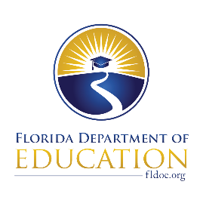
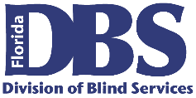
Florida Rehabilitation Council
for the Blind

December 22, 2016

U. S. Department of Education, OSERS
Rehabilitation Services Administration
Attn: Mary Williams
400 Maryland Ave., SW
Washington, DC 20202-2800

Dear Ms. Williams:

The Florida Rehabilitation Council of the Blind respectively submits its 2016 Annual Report as required by Section 105(C) (4) of the 1992 Amendment to the Rehabilitation Act. In accordance with 34 CFR 361.17, a copy of this report has been submitted to the Florida Governor’s Office.

This report presents our activities and recommendations for the 2015/2016 federal fiscal year to the Florida Division of Blind Services.

As the chair of the council, I would like to offer my appreciation and gratitude to the Division of Blind Services for its excellent support, and the council members for their diligence and contributions in serving Floridian’s with visual impairments.

If you have questions regarding this submission, please contact Selena Sickler assistant to the council at 850/245-0329.

Sincerely,

Robert Kelly, Chair
Florida Rehabilitation Council for the Blind

RK/ss

cc: Governor Rick Scott
Christyne Cavataio

2015-2016 MEMBERS
FLORIDA REHABILITATION COUNCIL FOR THE BLIND

Robert L. Doyle, III, Director
FDBS Rm 1114, Turlington Bldg.
325 W. Gaines St.
Tallahassee, FL 32399
(O) 850/245-0300
Robert.doyle@dbs.fldoe.org

State Director Ex-Officio

Term Expires: N/A

Jesus Garcia
5955 West 16th Lane
Hialeah, FL 33012
(H) (305) 654-8329
jesusg@logisticare.com

Representing: Former Clients
Term Expires: 2019

Leanne Grillot
BEES Rm 614, Turlington Bldg.
325 W. Gaines St.
Tallahassee, FL 32399
(O) (850) 245-0478
Leanne.Grillot@fldoe.org
Representing: State Educational Unit
Term Expires: 2016

Benedict Grzesik
535 N. Interlachen Ave. #301
Winter Park, FL 32789
(C) (321) 446-4899
bgrzesik@cfl.rr.com
Representing: Workforce Board
Term Expires: 2016

Patricia Lipovsky
1129 Bradenton Rd.
Daytona Beach, FL 32114
(H) 386-255-0288
plipovsky@cfl.rr.com

Representing: FL – IL Council

Term Expires: 2016

Victoria Magliocchino
332 Cypress Rd.
St. Augustine, FL 32086
(H) (904) 201-4760
vmagliocchino@fldeafblind.org

Representing: FL - Deaf-Blind Association

Term Expires: 2016

Lenora Marten
7175 Overland Park Blvd E.
Jacksonville, FL 32244
(c) (904) 229-9554
fopbc@aol.com

Representing: Parent Training Center

Term Expires: 2018

Sandra Burke
3748 Hyde Park Drive
Ft. Myers, FL 33905
(O) (239) 997-7797
SMartin@lighthouseswfl.org

Representing: Advocacy –Lion’s Club

Term Expires: 2017

Donte Mickens
4635 Danson Way
Delray Beach, FL 33445
(H) (561) 450 - 6149
Donte.Mickens@yahoo.com

Representing: Former Clients

Term Expires: 2016

Bruce A. Miles
590 Hammock Court
Marco Island, FL 34145
(H) (239) 394-1020
(F) (239) 394-1414
Brokerbruc@aol.com
Representing: Parents of the Blind
Term Expires: 2018

Gloria Mills
504 South Armenia Ave.
#1319-B
Tampa, FL 33609
(O) (813) 837-1100
gloria@irescue-tax.com

Representing: National Federation of the Blind

Term Expires: 2017

Robert Kelly, Chair
405 White Street
Daytona Beach, FL 32114
(O) (386) 258-3441
robert@conklincenter.org

Representing: Business and Industry

Term Expires: 2019

Sylvia Stinson-Perez
Lighthouse f/t Visually Impaired
8610 Galen Wilson Blvd.
Port Richey, FL 34668
(Pasco) (727) 815-0303
sperez@lvib.org

Representing: Rehabilitation Rehab Program

Term Expires: 2016

Charles Brooks, III
659 Parakeet Court
Kissimmee, FL 32759
(H) 863-496-4744
Eagle77732@yahoo.com
Representing: Blinded Veterans Association
Term Expires: 2017

Michael A. Wiseman
591 E. 15th Street
Hialeah, FL 33010
(C) 305-331-4870
wisemanmikey@gmail.com
Representing: Florida Council of the Blind
Term Expires: 2017

Paul Edwards
20330 N.E. 20th Court
Miami, Florida 33179
(H) 305-692-9206
Edwards.paul55@gmail.com
Representing: Business/ Industry
Term Expires: 2018

Howard Bell
1000 North Ashley Drive
Ste. 640
Tampa, Florida 33602
(C) 813-494-0497
howardb@DisabilityRightsFlorida.org
Representing: Client Assistance Program
Term Expires: 2019

Message from the FRCB Chairperson

The Florida Rehabilitation for the Blind (FRCB) is pleased to present its annual report for Federal Fiscal Year 2016 to the governor and other committed stakeholders. The year has been a busy one, requiring a great deal of learning, collaboration, planning and advocacy on the part of the Council and the Division of Blind Services (DBS) in response to the Work Innovative and Opportunity Act (WIOA). Collaboration included a joint statement developed with the Division intended to help guide development of the rules for WIOA, which was finalized in January 2016. We look forward to the increased interagency collaboration mandated by WIOA and are committed to implementing the new regulations in ways that improve employment outcomes for blind Floridians.

The FRCB elected new officers in February 2016: Robert Kelly was reelected for another term as Chairman, Patricia Lipovsky was elected as Vice Chairman and Donte Mickens was elected as 2nd Vice-Chair. The FRCB welcomed two new members: Howard Bell, representing the Client Assistance Program, and Paul Edwards, representing Business and Industry. Four members were reappointed: Bruce Miles, representing Parents of the Blind, Lenora Marten, representing Parent Training Center, Jesus Garcia, representing Former Clients and Robert Kelly, representing Business and Industry. The terms of eight members expired in September, five positions requiring new appointments and 3 positions requiring re-appointments. Currently, there are 9 vacant positions, and the FRCB is communicating regularly with the Governor’s appointment office on the status of screenings of current applications under consideration. In view of the important work entrusted to the Division of Blind Services and challenges faced by the Division in implementing the new WIOA provisions, it is important that stakeholders be fully represented on the Council.

The FRCB has worked closely with DBS in tracking of employment outcome information, and we are pleased that DBS is able to report significant improvement in this core area of its responsibilities.

The FRCB has continued to hold meetings at key locations around the state to maintain awareness about issues and accomplishments related to DBS regional service offices and community rehabilitation programs. These meetings continue to feature public forums which provide DBS with important feedback from consumers and stakeholders.

Robert Kelly
FRCB Chairman

Director’s Message
I am pleased to present you with the Florida Rehabilitation Council for the Blind Annual Report, a showcase of different initiatives and accomplishments achieved in this past year. As we reflect on the wonderful work of the FRCB and Florida’s Division of Blind Services, we must recognize our many outstanding successes.

Our members are passionate about making a difference in the lives of individuals living with visually impairments, and with that enthusiasm, we will enhance the impact of our programs.

FDBS has made great strides to increase employment outcomes for eligible individuals through various workgroups and strategic planning sessions that have been put in place. It is a priority for FDBS to ensure Floridians who are blind and visually impaired have the necessary tools to achieve success, which includes obtaining and maintaining employment. During this past state fiscal year, the Division provided employment services to 5335 customers, and helped 813 individuals gain, maintain or advance in successful employment.

Florida’s Division of Blind Services is committed to its continued working partnership with the Florida Rehabilitation Council for the Blind, our clients and stakeholders. I look forward to working with the Council to develop additional ways of keep Florida as a frontrunner in the areas of gainful employment, independent living and equality for individuals who are blind or visually impaired.

We have much to be proud of and we will continue to build on this solid foundation to raise achievements in the coming years.

Robert L. Doyle, III
Director Division of Blind Services

FRCB Accomplishments
- Governor Rick Scott announced two appointments and two reappointments to the Rehabilitation Council for the Blind on July 6, 2016 and three reappointments on September 21, 2016.
- Maintained its mission and focus on a strategic planning that is closely aligned with the priorities of the FDBS.
- Participated with the development of in the Unified State Plan.
- Elected new Officers at the first quarterly meeting in February 2016.
- Maintained a majority of blind Council members.
- Increased emphasis on collaboration between employers and the FDBS.
- Maintained the FRCB website with updated information regarding council members and future meeting dates and locations.
- Served as effective vehicle for cultivating meaningful partnerships between the FDBS and other stakeholders.
- Increased attention on FDBS’s performance goals and objectives.
- Held four quarterly meetings in October 2015, February 2016, May 2016 and July 2016.
- Conducted four public forums at each of its quarterly business meetings.
- Maintained an active role in the NCSRC by attending the 2015 Fall Training Session in Seattle, Washington to bring the information gained to the council members.
- Collaborated with the Florida State University (FSU) Survey Research Laboratory to conduct the Client Satisfaction Survey. Results of the Survey can be found on the FDBS website: http://FDBS.myflorida.com.
- The Client Satisfaction Subcommittee successfully completed their evaluation and revision of the 2014-2015 Survey, and the new survey is expected to be implemented in 2017.

Since April 2016, the Florida Division of Blind Services (DBS) has hosted several statewide ceremonies and expos in commemoration of its 75 years of fostering independence to blind and visually impaired Floridians. Ceremonies were held in Daytona, Fort Myers, West Palm Beach and Tallahassee.

In July 2016, the FRCB participated in the Regional Ceremony and Expo in Fort Myers for a daylong celebration of educational sessions, sensory activities for children, business networking opportunities and a technology/community expo. DBS also hosted Business luncheons to provide companies with information regarding training programs and the benefits of hiring individuals with visual impairments and other disabilities. FRCB Chairman spoke at the Ceremony and council member Paul Edwards gave a historical perspective

“Since 1941, DBS has made vast strides in attacking the barriers that have hindered persons with visual disabilities from fully participating in our society and our workforce,” DBS Director Robert L. Doyle, III, said. “This year, through partnerships with our community rehabilitation programs, the Division has assisted 841 individuals with achieving successful employment. As we look to the future, we continue to charge toward our goal of Florida being a barrier-free environment for residents with visual disabilities.”

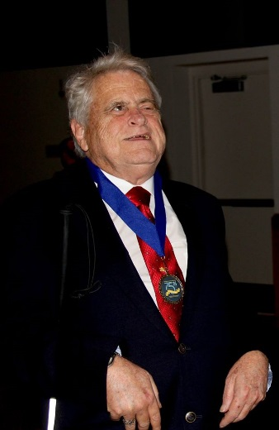
“As a state and nation, we have come a long way over the last 75 years in terms of how individuals with disabilities are treated, a fact in which all Floridians can take great pride,” said Commissioner of Education Pam Stewart. “I am honored that the Department of Education has been able to increase accessibility and inclusion for Floridians in the blind and visually impaired community, and we are committed to continue this progress so everyone benefiting from our system has the greatest opportunity for a successful future.”
Through DBS, blind and visually impaired Floridians have access to many educational, vocational, medical, social and recreational services beginning at birth.

As part of the anniversary ceremony, DBS has inducted several new members into the "Successful 75," an award program that recognizes individuals, organizations and businesses who have remained steadfast in the advancement of independence for persons who are blind and visually impaired.
Florida Division of Blind Services
Goals & Objectives

Comprehensive Statewide Needs Assessment
FDBS contracted with Mississippi State University to conduct a needs assessment. The assessment revealed the following areas of need for FDBS:
- Develop and strengthen greater employer relationships;
- Expand services to Hispanic/Latino, African American, American Indian and other populations that identify themselves as multiple races);
- Improve Assistive technology services such as standardizing curriculum, making an effort to stay up-to-date on the most in-demand technology and job skills, and reworking trainings to make them more frequent and/or in-depth;
- Increase outreach and community visibility;
- Assist clients in identifying transportation resources for employment;
- Engage with Community Rehabilitation Programs (CRPs) to maximize outcomes for consumers; and
- Regular follow-up with consumers.
In addition to the areas identified in the CSNA, FDBS conducted three public meetings to collect stakeholder input.
New goals and strategies were derived from stakeholder input, the FDBS strategic plan and results of the CSNA. Additionally, the goals and strategies were discussed with, and endorsed by the Florida Rehabilitation Council for the Blind. The newly established goals are intended to guide the FRCB as it reviews, analyzes and advises the FDBS. The FRCB provides recommendations regarding FDBS’s responsibilities relating to eligibility (including order of selection); the extent, scope and effectiveness of services provided; and functions performed by state agencies that affect or that potentially affect the ability of Floridians who are blind or visually impaired in achieving employment outcomes. These new goals and objectives are listed below:

Strategic Plan Goals
Goal 1: Highest Client Achievement

Objective: Coordinate and secure high-quality training, education, work experiences and partnerships that create opportunities for blind and visually impaired Floridians to obtain and maintain independence, post-secondary education credentials and successful employment outcomes.

Goal 2: Seamless Articulation and Maximum Access

Objective: Create a comprehensive service delivery system that fosters accessibility and provides positive experiences for blind and visually impaired Floridians enabling them to matriculate from school/training to work. Improve outreach methods to reach more consumers, advocates, providers, employers and other stakeholders.

Goal 3: Skilled Workforce and Economic Development

Objective: Assist blind and visually impaired Floridians with obtaining, maintaining and advancing in competitive integrated employment.

Goal 4: Quality Efficient Services

Objective: Create an accountable and exemplary division workforce that ensures high quality services.

You may read or download a full copy of the State Plan for the State Vocational Rehabilitation Services Program and State Plan Supplement for the State Supported Employment Services Program - Florida Department of Education - Division of Blind Services by using the web address below.
http://dbs.myflorida.com/Legal%20Resources/State%20Plan%20FY2015/index.html

FRCB Meetings and Public Forums

During each federal fiscal year, the FRCB meets quarterly (October, February, May and July). The meetings are held at various locations throughout the state. The Council determines if a public forum should be conducted at a meeting to receive consumer input on the effectiveness of services provided by the FDBS in assisting individuals with visual impairments achieving employment and independence under Title I of the Rehabilitation Act.
The FRCB held its October quarterly meeting on Wednesday, October 21, 2015 in Jacksonville at the Lexington Hotel and Conference Center Jacksonville Riverwalk. Nine council members were present and one via teleconference. The FRCB also held a public forum on Wednesday, October 21, 2015 in Jacksonville at the Lexington Hotel and Conference Center Jacksonville Riverwalk, Jacksonville. Ten consumers were in attendance. FRCB also held a second day of council business on Thursday, October 22, 2015. Ten council members were present.
The FRCB held its February quarterly meeting on Wednesday, February 10, 2016 in Tallahassee at the Division of Blind Services, Turlington Building. Nine council members were present and two via teleconference. The FRCB also held a public forum on Wednesday, February 10, 2016 in Tallahassee at the Division of Blind Services, Turlington Building. Two consumers were in attendance. FRCB also held a second day of council business on Thursday, February 11, 2016. Eight council members were present and one member participated via teleconference.

The FRCB held its May quarterly meeting and public forum on Thursday, May 12, 2016 in St. Augustine at the Florida School for the Deaf and Blind. Fourteen council members were present. The FRCB also held a public forum on Thursday, May 12, 2016 in St. Augustine at the Hampton Inn and Suites Vilano Beach. One consumer attended in person and one via teleconference. FRCB also held a second day of council business on Friday, May 13, 2016. Fourteen council members were present.

The FRCB held its July quarterly meeting and public forum on Thursday, July 28, 2016 in Ft. Myers at the Crowne Plaza Hotels and Resorts. Eleven council members were present and one via teleconference. The FRCB also held a public forum on Thursday, July 28, 2016 in Ft. Myers at the Florida Southwestern State College. Three consumer were in attendance. FRCB also held a second day of council business on Friday, July 29, 2016. Eleven council members were present.

Complete quarterly meeting and public forum minutes can be found on the FDBS website: http://FDBS.myflorida.com/Rehabilitation%20Council/meetings-minutes.html
FRCB Quarterly Meeting
Agenda Items

- Welcome, Introductions and Pledge of Allegiance

- Adoption of Agenda

- Director’s Report: Division of Blind Services Updates

- District Administrator’s Report

- Employer Recognition

- Local Community Rehabilitation Program Reports

- Client Satisfaction Survey Data Updates

- Division of Blind Services State Plan Updates

- Vocational Rehabilitation Goals Updates

- New Committee Appointments

- Bureau of Business Enterprise Update

- Workforce Innovation and Opportunity Act of 2014

- FDBS Budget Report and Legislative Updates

- Blind Services Foundation Update

- Updates on Outreach to Underserved/Unserved

- Strategic Plan Discussions

District Accomplishment Reports
The FRCB acknowledges the work done by districts toward achieving the FDBS’s goals, specifically those activities that increase the quality and quantity of employment outcomes. Over the past year, district staff from across the state participated in events that brought together employers, community rehabilitation partners (CRPs) and individuals seeking employment. Additionally, vibrant and innovative collaborations have been forged to provide employment opportunities and support systems for FDBS consumers. Notable highlights include:

October 2015, Jacksonville, Florida
District Administrator, Robert Lewis reported the districts efforts to focus on more community outreach to all social service agencies, churches, schools, etc. The district staff work very closely with four community rehab partners through increasing productivity, communication and collaboration.

February 2016, Tallahassee, Florida
District Administrator, Ana Saint-Fort continues to participate in community outreach to increase referrals as well as reach underserved populations in the rural areas. Monthly case management meetings are conducted to discuss client’s progress and any issues that may prolong the client reaching a successful outcome. The relationship among the district and the Lighthouse is one of mutual respect and professionalism were they can discuss and work through any concerns/challenges.

May 2016, St. Augustine, Florida
District Administrator Robert Lewis continues to focus on the consumers of the district. Making sure their needs are being met in a more efficient manner that directly lead to an increase in successful closures in employment. District Three proactively implemented regular meetings with Career Source and have strengthened that alliance leading to another successful relationship that provides more resources and opportunities for DBS clients. We are appreciative of the connection we have with City Government and have partnered with the City to work together to assist the entire disabled community. District Three works very closely with the community rehab partners in maintaining an open and productive line of communication.

July 2016, Fort Myers, Florida
District Administrator Bruce Emmerton reported that the primary focus of the district was on client services resulting in successful experiences in childhood, high school, college, job placement or improved quality of life through greater independence. Outreach activities continue to be an ongoing focus to create awareness in the community about the services of DBS.

Employer Recognition
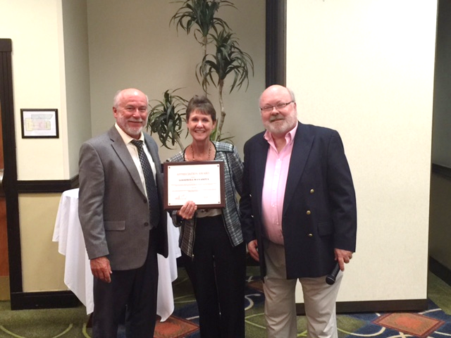
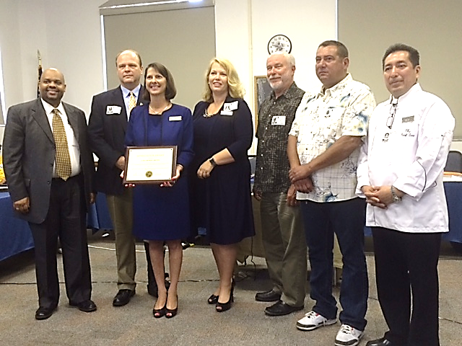
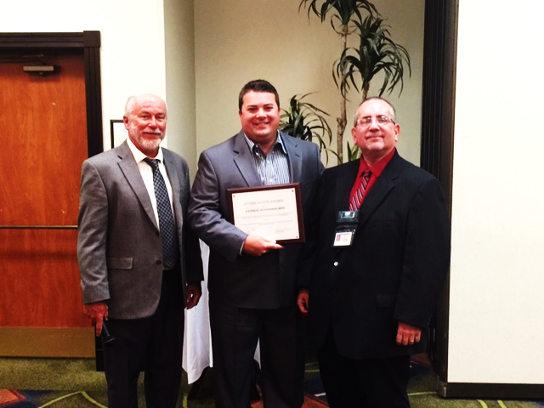

The Florida Rehabilitation Council for the Blind and the Division of Blind Services annually offers their gratitude to local businesses and employers who support FDBS by hiring and showing support towards individuals who are blind or visually impaired by creating a barrier free environment allowing them to obtain their independence.

The FRCB and FDBS presented the Appreciation Awards at each quarterly business meeting. This year the following employers were recognized:

- City of Jacksonville’s Division of Disabled Services, October 2015

- Tasty Pastry, February 2016

- Casa Monica Hotel of St. Augustine, May 2016

- Goodwill Manasota and J Lodge/Stateside BPO July 2016

2015-2016 FEDERAL FISCAL YEAR
FRCB EXPENSES

Customer Satisfaction Survey (2015-2016)

Beginning in 2004, the Florida Rehabilitation Council for the Blind decided to collect customer satisfaction data on a more “real time” basis. Rather than conduct one survey that included all of the clients who had their cases closed the preceding year, the Council decided to have the data collected on a monthly basis and review the results at their quarterly meetings. This report summarizes the data collected for the 2015-16 federal fiscal year, which includes cases closed between October1, 2015 and September 30, 2016. The Customer Satisfaction Survey of former Division of Blind Services (DBS) clients gathers perspectives of former DBS clients concerning program services, levels of satisfaction, and areas for program improvement. This report describes the methods used and presents the 2015-16 results for clients with cases closed between October 1, 2015 and September 30, 2016. In the fall of 2009, the Florida Rehabilitation Council for the Blind modified the previous survey to streamline the interviews and update information in new areas. Some minor modifications to this survey were made October 2010. Many of the items remained comparable or identical to the survey administered the previous 7 years. In these instances, data for the 13 previous years are provided for comparison purposes. For new questions, major modifications made to question wording, or questions asked of different populations (new screens), no comparisons to prior years can be made. In 2015, the Survey Research Laboratory at Florida State University provided a report for the federal fiscal year starting October 1, 2014 and ending on September, 2015. Data for the years of 2014 and the current year are based on the new schedule, while previous years report data collected from April 1st to March 31st.

SURVEY PROCEDURES

Population Surveyed. The Florida State University Survey Research Laboratory (SRL), College of Social Sciences, conducted a telephone survey of former Division of Blind Services (DBS) clients on a monthly basis. Employment-bound clients with cases “closed” between October 1, 2015 and September 30, 2016 comprises the population surveyed for this year-end report. DBS provided the names, addresses, phone numbers and demographic information for 1,393 former clients. Among them there was 1 client that did not have a phone number on record. Case closures are classified into two major groupings, those with successful and unsuccessful closures.

Overall Satisfaction

Client Satisfaction with the DBS program is high. To gauge the overall level of satisfaction with the DBS program, former clients were asked if they would recommend DBS services to others. During 2015-16, nearly all the clients, 95 percent (459 of 484), said, “Yes”, they would recommend DBS services to others. This is consistent with previous years’ results. Clients were also asked to rate their overall satisfaction with the program. During 2015-16, 89 percent of the clients (434 of 485) were either “Satisfied” or “Very Satisfied with the program. (See Q61 in Appendix B). Nearly the same percentage of clients with successful closure (94%) reported being “Satisfied” or “Very Satisfied” as clients with unsuccessful closure (82%).

http://FDBS.myflorida.com

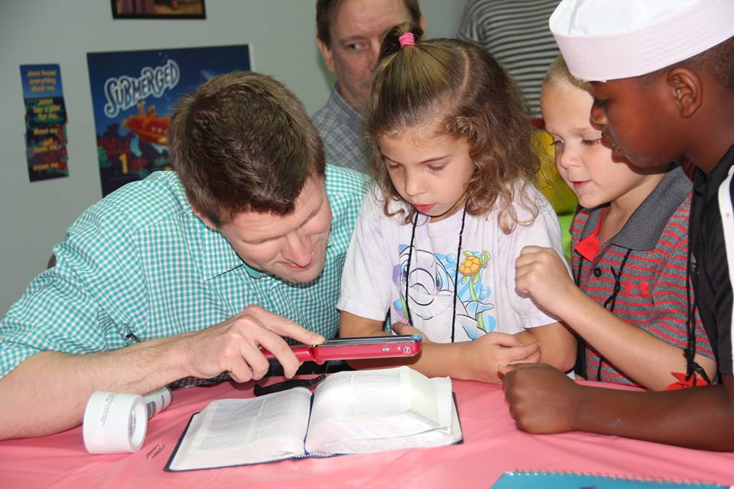

Outcomes

Florida DBS VR Performance Based Budget Measures

DBS VR Performance Based Data | FFY2012 | FFY2013 | FFY2014 | FFY2015 | FFY2016
Number of Customers Served | 5455 | 5418 | 5358 | 5287 | 5335
Number of Customers Successfully Closed | 740 | 690 | 721 | 772 | 813

Consumers Earnings Data –Federal Fiscal Year

 | FFY2012 | FFY2013 | FFY2014 | FFY2015 | FFY2016
Average # of Hours worked per week | 30.60 | 30.35 | 29.64 | 28.98 | 27.76
Average Hourly Wage | $12.55 | $13.41 | $13.54 | $13.96 | $12.98
Average Weekly Wage | $395.64 | $410.07 | $399.85 | $403.56 | $384.61
Projected Average Annual Earnings at Placement | $20,573.15 | $21,323.76 | $20,792.15 | $20,984.93 | $19,999.86
Average Case Cost | $5,837.92 | $7,083.19 | $6,929.03 | $7,953.80 | $8,288.05

Florida Rehabilitation Council
For the Blind
Ad Hoc Committees

EXECUTIVE COMMITTEE
The Executive Committee shall consist of the Chair, First -Vice Chair, Second -Vice Chair and the Chairs of each standing committee. The Executive Committee is as follows:

Robert Kelly, Council Chair
Patricia Lipovsky, First Vice Chair
Donte Mickens, Second Vice Chair
Bruce Miles, Chair, Planning Committee
Donte Mickens, Chair, Evaluation Committee

PLANNING COMMITTEE
The Planning Committee will report to the full council regarding activities authorized to be carried out under Section 105 of the Rehab Act, as amended, and assist in the preparation of the State plan and amendments to the plan, applications, reports, and needs assessments required by Section 105 of the Rehab Act, as amended and other programs. The Planning Committee is as follows:

Bruce Miles, Chair
Sheryl Brown
Ben Grzesik
Vicky Magliocchino
Lenora Marten
Jesus Garcia

Client Satisfaction Survey Subcommittee
The Client Satisfaction Survey Subcommittee evaluated and revised the 2014-2015 survey instrument in order to develop questions that are more clearly defined.

Bruce Miles
Mikey Wiseman
Sylvia Perez
Sandra Burke
Charles Brooks
Jesus Garcia
Robert Kelly
Paul Edwards
Robert Doyle

EVALUATION COMMITTEE
The Evaluation Committee will review, analyze, and report to the full council regarding the performance of the responsibilities of FDBS as required under Section 105 of the Rehab Act, as amended. The Evaluation Committee is as follows:

Donte Mickens, Chair
Sylvia Stinson-Perez
Leanne Grillot
Gloria Mills
Sandy Burke
Patricia Lipovsky
Charles Brooks
Michael Wiseman

Florida Rehabilitation Council for the Blind Biographies

BENEDICT F. GRZESIK
MELBOURNE

Ben Grzesik is the State Workforce Investment Board representative on the council.

He has extensive experience implementing strategic human resource and risk management departments and has served as a wealth analyst.

Currently on the Board of Workforce Florida, Inc. and is the chair for the Finance & Administration Council; also serving on the Florida Rehabilitation Council for the Blind, the Florida Rehabilitation Council and most recently on the United States Department of Education, Primary Study Group for the 37th Institute on Rehabilitation Issues.

For the past 10 years, he has been a member of the adjunct faculty in the virtual classroom for the University of Maryland University College teaching numerous Human Resources-related courses.

Grzesik holds a master’s degree in international administration and a
Bachelor’s degree in organizational behavior and is certified as a senior human resource professional and a member of the Society for Human Resources Professionals.

**********************************************
ROBERT KELLY
DAYTONA BEACH

Robert Kelly is one of four Business/Industry representatives on the Florida Rehabilitation Council for the Blind.

He is a certified rehabilitation counselor who has more than 30 years of experience in direct service provision and administration of services for people who are blind and visually impaired. Kelly currently serves as executive director of the Florida Lions Conklin Center for the Blind in Daytona Beach, Florida.

SANDRA BURKE
NORTH FORT MYERS

Sandra Martin is an Advocacy Group representative on the Florida Rehabilitation Council for the Blind representing the Florida Lions Club (LIONS).

She is a marketing representative and receptionist at the Lighthouse of SWFL in North Fort Myers, Fla. Blind since the age of 22, Martin lost her eyesight due to juvenile diabetes shortly after the birth of her daughter. This vibrant woman prides herself on being an active member of her community and always lives life to the fullest. Her love of life and dedication to helping others has made her the recipient of many awards and accolades including the Kenneth Shaw Goodwill International Award, Goodwill Graduate of the Year and Lion of the Year, just to name a few. Martin spent most of her years living in Naples, Fla. and her advocacy efforts were instrumental in bringing in more services for the blind to Collier County. One of her proudest achievements being the pivotal role she played as one of the founders of The Lighthouse of Collier. Martin was also an active member with the Naples Lions Club and was main catalyst for the audio crosswalk beeper installation. Having relocated the North Fort Myers area, she remains active in her outreach and advocacy efforts and continues to promote the importance of rehabilitation services for the blind throughout Lee, Hendry and Glades counties.

**********************************************
VICTORIA A. MAGLIOCCHINO
ST. AUGUSTINE

Victoria Magliocchino is an Advocacy Group representative on the Florida Rehabilitation Council for the Blind representing the Florida Deaf-Blind Association (FDBA).

She was born at an army base in Columbus, Ga. and grew up in Thornwood and Hawthorne, New York. Magliocchino attended New York School for the Deaf from 1961 to 1975, Gallaudet University in Washington, D.C. from 1975 to 1979, and Western Maryland College (currently McDaniel College) in Westminster, Md. in the summers of 1980, 1981 and 1982. She earned her bachelor’s degree in English from Gallaudet and master’s degree in deaf education from Western Maryland.

Magliocchino has taught language arts and mathematics at the Deaf Department High School at Florida School for the Deaf and Blind in St. Augustine for 35 years. She was the head sponsor of the Junior National Association of the Deaf 1979 to 1987. She also was the school yearbook advisor/journalism teacher for 12 years. She retired this past May.

Magliocchino has served FDBA as the president for the past seven years. She was instrumental in establishing FSSP (Florida Support Service Providers) project and hopes it will become a full-blown program in the near future to provide much needed SSP services to the Deaf-Blind community. She received 2013 SERID Outstanding Deaf/Hard of Hearing/Deaf-Blind.
She has three adult children. She was married for 21 years.

**********************************************
ROBERT L. DOYLE, III
TALLAHASSEE

Robert Lee Doyle, III was appointed the Director of the Division of Blind Services on June 20, 2013.

He served for four years as director of the Division for the Visually Impaired within the Department of Human Services in Delaware. He has 18 years of experience in human services and education and holds a bachelor’s degree in political studies and a master’s degree in public administration, both from the University of Illinois. Among other achievements, he has implemented initiatives that resulted in increased successful employment outcomes through the VR program and has also worked to expand food service and vending business opportunities through Delaware’s Business Enterprise program.

Robert places a high priority on customer service, accountability and positive relations with consumer groups and other stakeholders.

**********************************************
DONTÉ A. MICKENS
DELRAY BEACH

Donte’ Mickens is a Former Client representative on the Florida Rehabilitation Council for the Blind. He is a graduate of Florida State University where he received a master’s degree in management with a major in risk management/insurance and bachelor’s degrees in finance and risk management. He is also a graduate of the Florida School for the Deaf and Blind in St. Augustine, Fla.

Mickens previously worked for the Division of Blind Services as an analyst, primarily assisting the Division’s budget officer. He also mentored fellow university students and Division clients in previous years.

Mickens is a member of the Board of Directors for the National Organization for Albinism and Hypopigmentation (NOAH). He also serves as the organization’s treasurer.
Donté is a Paralympic medalist as a member of the Men’s U.S. National Goalball team, competing in the Paralympic Games in Athens, Greece and Beijing, China. He currently lives and works in the Delray Beach/Boca Raton area as a senior financial analyst with NCCI, Inc.

**********************************************
BRUCE A. MILES
MARCO ISLAND

Bruce Miles represents the Parent of Blind on the Florida Rehabilitation Council for the Blind.

He moved to Florida from Chicago, Ill. in 1972, along with his wife, Sheila, and son, Troy. He has been actively engaged in the Real Estate Business on Marco Island since 1974. Miles owned and operated Gulf Coast Realty of Marco Inc. for many years and now associated with Anchor Real Estate of Marco.

Miles is currently the chair of the Florida Rehabilitation Council for the Blind and treasurer of the Blind Services Foundation. He is a charter member and past president of Marco Island Area Association of Realtors. He was past president of Marco Island Multi List Inc. Miles has served on many committees with the Florida Association of Realtors (FAR) and was chairman of The Professional Standards and The Resort and Second Home committees.

He was very active on the local level, including director of The Marco Island Fair Water Defense Fund committee (negotiating a buy out of the local water utility). He is a three-term past president of the Marco Island Lions Club, currently serving as their tail twister and a board member. He is the past director on the board of the Lighthouse of Collier.

Miles is no stranger to The Division of Blind Services, he served on their advisory council from 1985 to 1995 and then on Florida Rehab Council for the Blind from 1995 to 2001. His current appointment was made October 2008.

In his spare time, he enjoys travel (particularly cruising), swimming, boating and cooking.
LEANNE GRILLOT
TALLAHASSEE

Leanne Grillot is the State Educational Unit (IDEA) representative on the Florida Rehabilitation Council for the Blind.

Since 2011, she has been working for the Bureau of Exceptional Education and Student Services as a specialist for programs serving students who are visually impaired, deaf/hard of hearing, and dual-sensory impairments. Grillot has extensive experience as a teacher of the visually impaired and orientation and mobility specialist having been in the field for 20 years. Additionally, she assists with questions regarding assistive technology, Florida Alternate Assessment, National Instructional Materials Access Standard, and Online Learning for Students with Disabilities.

**********************************************
JESUS GARCIA
MIAMI

Jesus Garcia is one of four Business/Industry representatives on the Florida Rehabilitation Council for the Blind.

He is employed with LogistiCare, a company specializing in transportation. LogistiCare provides management services for government and private transportation systems. He graduated from Florida State University with a bachelor’s degree in business administration and a minor in computer science. Hobbies include reading, music, politics and all fields in the sciences. Garcia has been totally blind since birth and is active in the blind consumer movement, a member of the Florida Council of the Blind and its parent organization the American Council of the Blind.
**********************************************

GLORIA MILLS
TAMPA

Gloria Mills is one of four Business/Industry representatives on the Florida Rehabilitation Council for the Blind.

After 24 years with the Internal Revenue Service, she retired and started her own business as an Enrolled Agent/Tax Consultant in 1996. An EA is granted a license to represent taxpayers in matters of IRS Collections or Examinations as well as in tax court. Mills enjoys working in the community on causes relating to disabilities or transportation. In 1999, she served on the Committee of 99 representing consumers. Mills is proud to have the honor of being awarded the 1000 Points of Light Award by former state of Florida Gov. Jeb Bush. One of her most notable accomplishments is that she purchased the building in which she operates her company in 2008. She has served on various Boards of Directors, including the Florida Alliance for Assistive Services and Technology (FAAST), NAWBO, NFB and Self-Reliance, Inc.

**********************************************
SYLVIA STINSON-PEREZ
PORT RICHEY

Sylvia Stinson-Perez is the Community Rehab Center representative on the Florida Rehabilitation Council for the Blind.

She is the executive director of the Lighthouse for the Visually Impaired and Blind (LVIB), which serves Pasco, Hernando and Citrus counties. She has more than 12 years in the field of vision rehabilitation. Stinson-Perez has master’s degrees in social work and in visual disabilities from Florida State University. She is actively involved in Florida Association of Education and Rehabilitation for the Blind and Visually Impaired.

Stinson-Perez is visually impaired, and it is one of her goals to ensure that persons who are blind or visually impaired receive the training that will ensure they will live independent and successful lives, and to help the general community realize that persons who are blind can be and are competent, normal, successful people.

She is the proud mother of Olivia, 15 years old, and a guide dog named Carmel.

**********************************************
LENORA MARTEN
JACKSONVILLE

Lenora Marten is the Parent Training Center representative for the Florida Rehabilitation for the Blind.

She currently volunteers within the blind community by serving as president, Florida Organization of Parents of Blind Children and secretary for the National Federation of the Blind. Ms. Marten believes that given the opportunity, education and tools to succeed, blind people can lead independent, productive lives.
Lenora resides in Jacksonville, Fla. with her husband and son. She is an accomplished cosmetologist specializing in color and design.
PATRICIA LIPOVSKY
DAYTONA BEACH

Patricia Lipinski is the Florida Independent Living Council representative for the Florida Rehabilitation Council for the Blind.

She is originally from New Jersey, which is where she received her education, got married and started a family. Marten is a proud mom of three children and six grandchildren. Although she considers herself to be retired for the most part, she enjoys dabbling in real estate and property management, which she has done for several years. She also advocates for people with disabilities throughout the state of Florida, encouraging equal accessibility and opportunity for all.

In addition to serving on the FRCB council, Patricia also serves on the Florida Independent Living Council (FILC), is the treasurer of the Handicapped Adults of Volusia County (HAVOC), and the president of the Coalition and Concerns of the Totally Blind (CCTB.) In addition to her role on several committees in her local community, she also serves as a board member on the Friends of Library Access, which supports the Braille and Talking Books Library in Daytona Beach in providing audio books to the print impaired throughout the State of Florida, and sits on two state committees of the Florida Council of the Blind.

Her major in college was psychology and business, with a mission to help people, wherever and whenever she can. Her favorite quotes are “Where there is a will, there is a way,” and “If God brings you to it, he will bring you through it.”

**********************************************
CHARLES BROOKS
Kissimmee

The Rev. Charles Brooks, III is the Florida Blinded Veterans of America representative for the Florida Rehabilitation Council for the Blind.

He is a United States Air Force veteran. Originally from Sacramento, Cali., he served in the United States Air Force from 1970 to 1985 with an honorable discharge. A life member of the Disabled American Veterans, Blind Veterans National Chapter, he has assisted visually impaired veterans by making them aware of the benefits and guiding them to the correct place to have their needs met.

Active in the Greater Orlando Chapter of the Blind (GOCB) a local chapter, the Rev. Brooks co-hosted the radio show “Blind Matters Radio” out of Orlando, Fla. He attended Paul Quinn College in Waco, Texas, College of the Air Force in Azusa Pacific, N.Y., and Rhema Bible Training Center in Broken Arrow, Okla. He has a ministerial and pastoral degree.

***********************************************

PAUL EDWARDS
MIAMI

I was born in San Francisco California and was one of the early users of an incubator after being very premature. I was left with a little light perception which soon went away. At the age of seven I moved to Calgary Alberta Canada and went to school in Vancouver, British Columbia. At thirteen, my mother decided we were moving to Jamaica and I stayed there till I was 21. I graduated from high school sort of and completed my Bachelor's SPECIAL Honors degree in History at the Mona Jamaica campus of the University of the West Indies. I was the first blind student to go there and ended up in Trinidad because I wanted to do a graduate degree in international relations which I successfully completed.
I met my first wife there and married during my degree and so was faced with the need to find a way to support her and my first daughter who was pretty quickly on the way after our marriage. I taught at a small school in the rural area of Trinidad partly because there was no other job and partly because I was not sure if I could really teach. I really enjoyed that first year because all the girls I taught really wanted to learn. Yes, it was a girls' school. I was not making disparaging remarks about boys!
After one year I became the senior history master at Trinity College, the leading Anglican School for Boys in Trinidad and Tobago. Near the end of my teaching career, I got a graduate degree in Education from the University of the West Indies in St. Augustine, Trinidad.
When I left Trinidad ten years later I had three children: two girls and a boy. I moved to Florida where I went to work for the Division of Blind Services as a rehabilitation teacher. In this job, I went to people's homes and taught them skills that would enable them to adjust to visual impairment. After three years of this, I became a Rehabilitation Counselor and worked mostly with high school and college students. In 1983, I moved to Jacksonville to take over as Executive Director of an agency serving blind people there. In 1986, I moved to Miami as Director of Services to Students with Disabilities on the North Campus of Miami Dade College, the largest two year college in the United States. On my campus we served over seven hundred disabled students a year. I retired from that job in May of 2012.
While I certainly regard my working life as rich and varied, I have derived much more pleasure from the work I have done as a volunteer and advocate. I have worked at the local level, at the state level and at the national level to try to make things better for people who are blind. I currently serve on the Florida Rehabilitation Council for the Blind, the National Accreditation Council Board and hold several positions within the American Council and its Florida Affiliate. I have worked particularly on library issues, promoting braille and changing laws.
I absolutely believe that I have been given as much by the people I have tried to help as I have given them. Until I became associated with ACB, I saw myself as an inferior creature desperately trying to compete in a world where I could never do quite enough to be accepted. What the blindness movement taught me is that the only person I have to satisfy is me. That may sound arrogant and overbearing but that is not how it is intended. I set high standards for myself and if I can meet them I am likely to meet the standards of others. I no longer worry about being accepted by society. I have rights and I will fight to see they are protected. Society does not need to accept me but they do need to include me. I am proud to be a person who is blind. I am proud of what I accomplish every day in spite of the barriers that are there. More than that, I am proud of what every blind person everywhere accomplishes every day. It
Isn’t easy to be blind and anybody who says it is or who suggests that it's a walk in the park does not live in the same world I do!
I enjoy modern folk music, fantasy and science fiction and hope that, in due course, I will find some time to write. The one thing you can be sure I will not write is an autobiography. My three children are now grown up and I have ten grandchildren which is quite enough to keep me occupied and young. I still have a lot to do and many places where I think I can help. I have had a good life and only wish I had not been quite so busy. When you don't make time to smell the roses, they have often faded before you can enjoy them!

***********************************************

Howard Bell
St. Petersburg

Howard Bell is a Senior Advocate Investigator with Disability Rights Florida since 2002. He earned an Associate of Arts degree from Santa Fe Community College and a Bachelor of Science degree in Psychology from Florida State University. He is a certified DUI instructor by the Florida Department of Highway Safety and Motor Vehicles. He served on the National Disability Rights Network’s Client Assistance Program Advisory Committee. He now serves on the Committee to Advocacy for Persons with Impairment for the City of St. Petersburg, the Professional Advisory Committee and the RSA Scholarship Project Advisory Committees to the University of South Florida.

FRCB Application Process for Appointment

The governor appoints the members of the council in accordance with Section 105 of the Rehab Act and Chapter 413.011, Florida Statutes. Appointments are for three-year terms. A majority of the council shall be persons who are: (1) blind, and (2) not employed by the division.

The council is composed of at least one representative from the following:

- Independent Living Council (ILC)
- Parent Training & Information Center
- Client Assistance Program (CAP)
- VR Counselor (ex officio if staff)
- Community Rehabilitation Program Service Provider (CRP)
- Former applicant of VR services (two positions)
- State Educational Agency (IDEA)
- State Workforce Investment Board (SWIB)
- Four with Business, Industry & Labor

- Disability Advocacy Groups
  - Florida Council of the Blind (FCB)
  - National Federation of the Blind (NFB)
  - Blinded Veterans Association (BVA)
  - Florida Association of the Deaf-Blind (FADB)
  - LIONS
- Director of Division of Blind Services (Serves Ex-Officio Member)
- One Division of Blind Services (FDBS) employee serves as the Council’s staff
The Gubernatorial Appointments Questionnaire can be found at www.flgov.com/appointments. When you’re on the website, click Gubernatorial Appointments. When the questionnaire opens, you will see different sections on the left. Click on Boards of Interest, and then click on the drop down list of Board Name. All the boards listed under Board name have seats that are vacant or expired or soon to be expiring.

Questions regarding the Council or the application process may be directed to:

Florida Rehabilitation Council f/t Blind or Office of Governor Rick Scott
Florida Division of Blind Services Appointments Office
325 West Gaines Street Telephone (850) 717-9243
Tallahassee, Florida 32399 Fax: (850) 921-0733
Telephone :( 850) 245-0300
Fax: (850) 245-0363

CONNECT WITH DBS

http://DBS.myflorida.com/

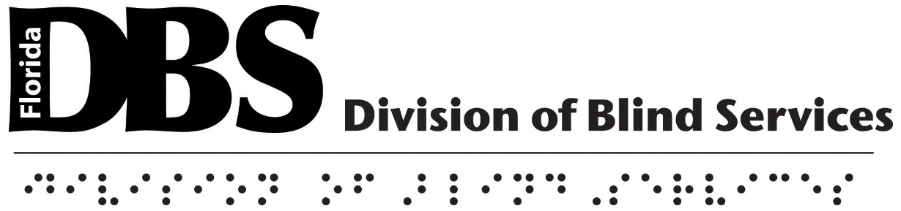

Florida Rehabilitation Council for the Blind
Florida Department of Education
Administrative Offices
325 West Gaines Street
Tallahassee, FL 32399
850-245-0300 • 1-800-342-1828

