Florida
Rehabilitation Council
For the
Blind
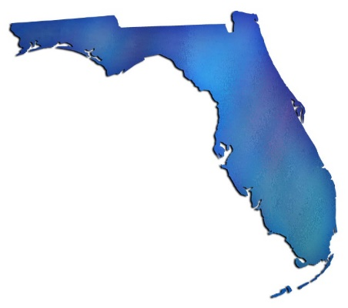
2018 Annual Report

Enclosed is a copy of the Florida Rehabilitation Council for the Blind’s (FRCB) Federal Fiscal Year 2018 Annual Report to the Commissioner of the Rehabilitation Services Agency and Governor Rick Scott.
Please contact Government Operations Consultant to the FRCB Selena Sickler if you have questions or comments regarding its contents. She can be reached at
Selena Sickler
Florida Division of Blind Services
325 W. Gaines Street, Room 1114,
Tallahassee, FL 32399
Phone (850) 245-0329
Selena.Sickler@dbs.fldoe.org
Thank you for your interest in and support of programs that provide and promote the use of vocational rehabilitation and independent living programs for Floridians who are blind or visually impaired.

If you would prefer a copy of this report in an alternative format, please contact the Florida Division of Blind Services at (850) 245-0300 or toll free at (800) 342-1828.

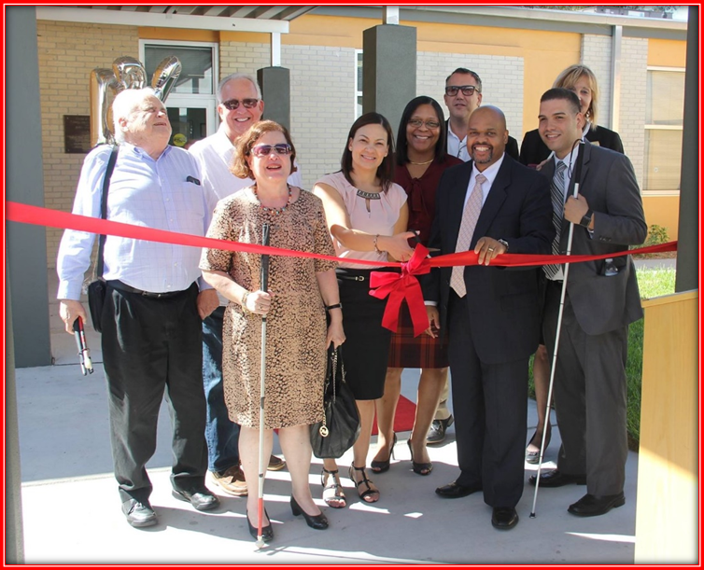
Tampa District Office Grand Reopening

Table of Contents
Message from the Chairperson 5
Directors Message 6
FRCB Mission 7
2017-2018 Council Members & Bios 8
DBS Mission Statement 14
Accomplishments 15
Strategic Plan Goals 16
DBS District Offices 17
Quarterly Meetings and Public Forums 18
Employer Recognition 19
Expenses 22
Customer Satisfaction Survey (2017-2018) 23
Outcomes 25
Committees 27
How to become a FRCB Member 28

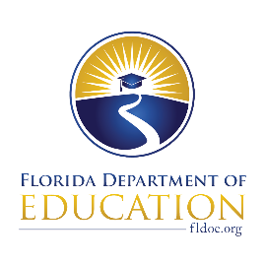
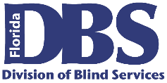
Florida Rehabilitation Council
For the Blind

December 13, 2018

U. S. Department of Education, OSERS
Rehabilitation Services Administration
Attn: Mary Williams
400 Maryland Ave., SW
Washington, DC 20202-2800

Dear Ms. Williams:

The Florida Rehabilitation Council of the Blind respectively submits its 2018 Annual Report as required by Section 105(C) (4) of the 1992 Amendment to the Rehabilitation Act. In accordance with 34 CFR 361.17, a copy of this report has been submitted to the Florida Governor’s Office.

This report presents our activities and recommendations for the 2017-2018 federal fiscal year to the Florida Division of Blind Services.

As the chair of the council, I would like to offer my appreciation and gratitude to the Division of Blind Services for its excellent support, and the council members for their diligence and contributions in serving Floridian’s with visual impairments.

If you have questions regarding this submission, please contact Selena Sickler assistant to the council at 850/245-0329.

Sincerely,

Robert Kelly, Chair
Florida Rehabilitation Council for the Blind

PL/ss

cc: Governor Rick Scott
Christyne Cavataio

The Florida Rehabilitation Council for the Blind (FRCB) is pleased to present its annual report for Federal Fiscal Year 2018 to the governor and other committed stakeholders. In 2018, there was an increased effort on collaboration, planning and advocacy on the part of the Council and the Division of Blind Services (DBS) in order to improve employment outcomes for Floridians who are blind or have low vision.

Message from the Chairperson
The FRCB elected new officers in February 2018: Robert Kelly was re-elected as Chairman, Michael Wiseman was elected as Vice Chair and Paul Edwards was elected as 2nd Vice Chair.
The FRCB had 4 appointments and 1 reappointment in 2018: Rose Conry, representing State Workforce Development Board; Paul Kurtz, representing former clients; Denise Valkema, representing advocacy groups; Louise Peyton, representing counselors; Mikey Wiseman, representing disability advocacy groups. The FRCB is communicating regularly with the Governor’s appointment office to fulfil vacancies on the Council as soon as possible.
The FRCB has worked closely with DBS in tracking of employment outcome information and will continue to do so. We are pleased that DBS is able to report significant improvement in this core area of its responsibilities.
The FRCB has continued to hold meetings at key locations around the state to highlight accomplishments and maintain awareness about issues related to DBS regional service offices and community rehabilitation programs. These meetings continue to feature public forums which provide DBS with important feedback from consumers and stakeholders in an effort to provide the best services possible for DBS clients.

Robert Kelly
FRCB Chairman
The Florida Division of Blind Services (DBS) has enjoyed a successful year by providing services for FFY 2017-2018 to 5031 customers, and helped 856 individuals gain, maintain or advance in successful employment. These accomplishments are a collaborative effort of staff, providers, advocates and stakeholders.

Directors Message

The Florida Rehabilitation Council of the Blind continues to develop a strong partnership with DBS to assist toward the common goal of maximizing employment and independent living for people who are blind or have low vision.

DBS has had a successful year by improving the quality of services, expanding outreach activities and creating awareness of the agency and the services it provides.

The Division of Blind Services will continue to build on its successes through collaboration and communication with core partners as we remain focused on delivering quality services for Floridians in the blind or visually impaired community.

Robert L. Doyle, III
Director Division of Blind Service

FRCB Mission
The Florida Rehabilitation Council for the Blind reviews, analyzes & advises on the policy decisions and evaluates the effectiveness of the Florida Division of Blind Services to ensure meaningful access to and use of vocational rehabilitation and independent living programs for Floridians who are blind or visually impaired.

Vision Statement

The Florida Rehabilitation Council for the Blind functions to create a positive impact on the fairness, efficiency, and accessibility of services through the evaluation of consumer feedback and the Florida Division of Blind Services performance.

Council Composition
- Independent Living Council (FILC)
- Parent Training & Information Center
- Client Assistance Program (CAP)
- VR Counselor (ex officio if staff)
- Community Rehabilitation Program Service Provider (CRP)
- Former applicant of VR services (two positions)
- State Educational Agency (IDEA)
- Parent, family member, guardian, advocate, or authorized representative of a blind person.
- State Workforce Investment Board (SWIB)
- Four with Business, Industry & Labor
- Disability Advocacy Groups
- Director of Division of Blind Services (Serves Ex-Officio Member)
- One Division of Blind Services (FDBS) employee serves as the Council’s staff

2017-2018 Council Members & Bios

Nicole Attong, LMHC
Director of FIU Embrace Florida Independent Living Council
Nicole Attong is the Florida Independent Living Council representative for the Florida Rehabilitation Council for the Blind.
Nicole is a Licensed Mental Health Counselor with more than 15 years of experience working with children, youth and families in the human services field in Miami-Dade and Monroe counties. Ms. Attong graduated with a M.A. in Mental Health Counseling and has spent her career working for underserved populations. She has served in leadership positions in both the child welfare and mental health and substance abuse systems in Miami-Dade County, and was also the Executive Director for the Community Based Care Alliance. Ms. Attong has experience in capacity building, implementing evidence-based practices and convening solution focused groups of providers, stakeholders and constituents around social justice issues. She has also served as the Project Director for the evaluation of the child-welfare system in the Southern Region, and two federally funded systems of care grants in Miami. Currently, Ms. Attong serves on two national workgroups aimed at improving the mental health and well-being of children, youth and families. She is a member of the Community Based Care Alliance Board, the Humana Behavioral Health Practitioner Advisory Panel for the Autism Spectrum Disorder Center of Excellence, the Commission on Disability Issues and Florida Independent Living Council.
Howard Bell
St. Petersburg Client Assistance Program

Howard Bell is the Client Assistance Program representative for the Florida Rehabilitation council for the Blind.

Howard has served as a Senior Advocate Investigator with Disability Rights Florida since 2002. He earned an Associate of Arts degree from Santa Fe Community College and a Bachelor of Science degree in Psychology from Florida State University. He is a certified DUI instructor by the Florida Department of Highway Safety and Motor Vehicles. He served on the National Disability Rights Network’s Client Assistance Program Advisory Committee. He now serves on the Committee to Advocacy for Persons with Impairment for the City of St. Petersburg, the Professional Advisory Committee and the RSA Scholarship Project Advisory Committees to the University of South Florida.

Rose Conry
Jacksonville State Workforce Investment Board
Rose Conry is the CareerSource representative on the Florida Rehabilitation Council for the Blind.
Ms. Conry is the Chief Executive Officer and co-founder of Stafftime, an award-winning full-service staffing company based in Jacksonville. Ms. Conry is a member on the Jacksonville Chamber of Commerce, and is active on a number of affiliated boards. She lives in Orange Park.

Robert L. Doyle, III
Tallahassee Director, Division of Blind Services

Robert Lee Doyle, III was appointed the Director of the Division of Blind Services on June 20, 2013.

He served for four years as director of the Division for the Visually Impaired within the Department of Human Services in Delaware. He has 18 years of experience in public service, including roles in human services education public policy. Director Doyle holds a Bachelor’s Degree in Political Studies and a Master’s Degree in Public Administration, both from the University of Illinois. Among other achievements, he has implemented initiatives that resulted in increased successful employment outcomes through the Vocational Rehabilitation program and has also worked to expand food service and vending business opportunities through Delaware’s Business Enterprise program.

Mr. Doyle places a high priority on customer service, accountability and positive relations with consumer groups and other stakeholders.

Paul Edwards
Miami Business/ Industry and Labor

Paul Edwards is one of the Business/ Industry representatives on the Florida Rehabilitation Council for the Blind.
A native of San Francisco, Paul Edwards was born with very little light perception, which soon led to total blindness. He graduated from high school and completed his bachelor's SPECIAL honors degree in history at the Mona Jamaica campus of the University of the West Indies. He was the first blind student attend the college. He later earned his graduate degree in international relations.
Mr. Edwards taught at a small school in the rural area of Trinidad. After one year, he became the senior history master at Trinity College, the leading Anglican School for Boys in Trinidad and Tobago. Near the end of his teaching career, he earned a graduate degree in education from the University of the West Indies in St. Augustine, Trinidad. When he left Trinidad, he moved to Florida where worked for the Division of Blind Services as a rehabilitation teacher. In this job, he went to homes and taught people skills that would enable them to adjust to visual impairment. After three years, he became a Rehabilitation Counselor and worked mostly with high school and college students. In 1983, he moved to Jacksonville to take over as Executive Director of an agency serving the blind. In 1986, he moved to Miami to serve as the Director of Services to Students with Disabilities on the North Campus of Miami Dade College. On this campus, staff served more than 700 disabled students a year. He retired May of 2012.
He has worked at the local, state and national level to advocate for persons who are blind. He currently serves on the Florida Rehabilitation Council for the Blind, the National Accreditation Council Board and hold several positions within the American Council and its Florida affiliate.
Robert Kelly
Daytona Beach Business / Industry and Labor

Robert Kelly was re-elected as the Chairman in February 2018. He is one of four Business/Industry representatives on the Florida Rehabilitation Council for the Blind.
He is a certified rehabilitation counselor with more than 30 years of experience in direct service provision and administration of services for people who are blind and visually impaired. Mr. Kelly currently serves as executive director for the Florida Lions Conklin Center for the Blind in Daytona Beach, Fla.
Paul Kurtz
Jacksonville Former Client

Paul Kurtz was born in Jacksonville, FL in March 1952. He attended public schools in Duval County graduating with honors from Robert E. Lee High School in 1970. He attended Florida Southern College graduating with honors in 1974 with a B.A. in psychology. He then attended Florida State University, graduating in 1977 with an M.S. Degree in counseling, health, and rehabilitative services. Mr. Kurtz later earned an A.S. Degree from Florida State College in computer science.
Mr. Kurtz has served as a rehabilitation instructor, EEO Specialist (Counselor) for the Department of the Navy, a computer programmer, ssems, analyst, and a systems administrator.
Mr. Kurtz is a strong believer in community service and has been so since his Eagle Scout and other projects in high school. He served on the Mayor’s Disability Council for the city of Jacksonville and was chairman. He served as chair of the Captain’s EEO Advisory Committee at the Fleet Readiness Center, Jacksonville, and he served previously on the Florida Rehabilitation Council. Mr. Kurtz believes that concerned and capable people can indeed make a difference.

Patricia Lipovsky
Daytona Beach Former Client

Patricia Lipovsky is the representative for former clients on the Florida Rehabilitation Council for the Blind.

A native of New Jersey, Ms. Lipovsky advocates for people with disabilities throughout the state of Florida, as well as her local community, encouraging equal accessibility and opportunity for all. Patricia’s college majors were business and psychology, and is the proud mom of three children and six grandchildren. Although she considers herself to be retired for the most part, she enjoys dabbling in real estate and property management, which she has done for several years.

In addition to serving on the FRCB council, Patricia also served on the Florida Independent Living Council (FILC), for several years, was the President and Treasurer of the Handicapped Adults of Volusia County (HAVOC), and served as the president of the Coalition and Concerns of the Totally Blind (CCTB.) In addition to her role on several committees in her local community, she also serves as a board member on the Friends of Library Access, which supports the Braille and Talking Book Library in Daytona Beach by providing audio books to the print impaired throughout the State of Florida. Ms. Lipovsky is a member of the Lions Club, and sits on two state committees of the Florida Council of the Blind.

Her mission is to help people, wherever and whenever she can. Her favorite quotes are “Where there is a will, there is a way,” and “If God brings you to it, he will bring you through it.”

Lenora Marten
Jacksonville Parent Training Center

Lenora Marten is the Parent Training Center representative for the Florida Rehabilitation for the Blind.
She currently volunteers within the blind community by serving as the President for the Florida Organization of Parents of Blind Children and Secretary for the National Federation of the Blind. Mrs. Marten believes that given the opportunity, education and tools to succeed, blind people can lead independent, productive lives.

She resides in Jacksonville, Fla. with her husband and son. She is an accomplished cosmetologist specializing in color and design.

Bruce A. Miles
Marco Island Parent of Blind

Bruce Miles represents the Parent of Blind on the Florida Rehabilitation Council for the Blind.
He moved to Florida from Chicago, Ill. in 1972, along with his wife, Sheila, and son, Troy. He has been actively engaged in the Real Estate Business on Marco Island since 1974. Mr. Miles owned and operated Gulf Coast Realty of Marco Inc. for many years and now associated with Anchor Real Estate of Marco.

In addition to serving on the FRCB, Mr. Miles is also the treasurer of the Blind Services Foundation of Florida. He is a charter member and past president of Marco Island Area Association of Realtors. He was past president of Marco Island Multi List Inc. Mr. Miles has served on many committees with the Florida Association of Realtors (FAR) and was chair of The Professional Standards and The Resort and Second Home committees.

He was very active on the local level, including director of The Marco Island Fair Water Defense Fund committee – negotiating a buy out of the local water utility. He is a three-term past president of the Marco Island Lions Club, currently serving as their tail twister and a board member. He is the past Director on the board of the Lighthouse of Collier.

Miles is no stranger to The Division of Blind Services. He served on their advisory council from 1985 to 1995 and then on Florida Rehab Council for the Blind from 1995 to 2001. His current appointment was made July 6, 2016.

In his spare time, he enjoys travel, swimming, boating and cooking.

Louise Peyton
Tampa Counselors

Louise Peyton is the representative for counselors on the Florida Rehabilitation Council for the Blind.

Ms. Peyton is retired as a former Division of Blind Services Rehabilitation Specialist for 36 years. She is a resident of Tampa who desires to serve the community and state. Ms. Peyton’s expectation is to learn about services to the blind and visually impaired residents of Florida and to aid with the continuation of those services.
Denise Valkema
Miami Advocacy Group

Denise Valkema is the National Federation of the Blind representative on the Florida Rehabilitation Council for the Blind.

Ms. Valkema is a member of the National Federation of the Blind and currently serves as the President of the National Federation of the Blind of Florida since 2015. Ms. Valkema graduated with an Associate in Arts Degree and Associate in Science Degree in Early Childhood Education from Miami Dade College. She received her Bachelor Degree in Elementary Education from Clearwater Christian College.

Ms. Valkema was appointed to the Miami Dade County Commission on Disability Issues from 2004-2012. She currently serves on the Miami Dade County Local Coordinating Board.

Michael Wiseman
Miami Advocacy Group

Michael Wiseman is an Advocacy Group representative on the Florida Rehabilitation Council for the Blind representing disability groups that include representatives of individuals with disabilities who have difficulty representing themselves or unable to represent themselves.

Mr. Wiseman serves as the First-Vice Chair on the Florida Rehabilitation Council for the Blind, the Chairman on the Florida Rehabilitation Council, and the First Vice President on the Florida Council of the Blind.

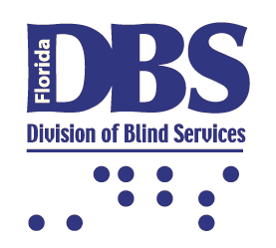

DBS Mission Statement
To ensure blind and visually impaired Floridians have the tools, support and opportunity to achieve success.

DBS Vision Statement

In partnership with others, create a barrier free environment in the lives of Floridians with visual disabilities.

- Governor Rick Scott announced four appointments and one reappointment on January 26, 2018.

Accomplishments
- Maintained its mission and focus on strategic planning that is closely aligned with the priorities of the Florida Division of Blind Services.
- Provided input in DBS policy revisions.
- Elected a new Chairperson, First Vice Chairperson and Second Vice Chairperson at the first quarterly meeting in February 2018.
- Elected new members to serve on the Evaluation and Planning Committees.
- Strengthened its working relationship with other councils within the state as required under Sec 105 of the Rehab Act.
- Served as effective vehicle for cultivating meaningful partnerships between the FDBS and other stakeholders.
- Increased attention on FDBS’s performance goals and objectives.
- Held four quarterly meetings in Lakeland, Fort Lauderdale, West Palm Beach and Orlando.
- Conducted four public forums at each of its quarterly business meetings.
- Maintained an active role in the NCSRC by attending the 2018 Spring Training in Bethesda, Maryland.
- Collaborated with the Florida State University (FSU) Survey Research Laboratory to conduct the Client Satisfaction Survey. The results for SFY 2018 can be found in the annual report located on the FDBS website by following the link: Florida Division of Blind Services Website.

Strategic Plan Goals
Goal 1: Highest Client Achievement
Objective: Coordinate and secure high-quality training, education, work experiences and partnerships that create opportunities for blind and visually impaired Floridians to obtain and maintain independence, post-secondary education credentials and successful employment outcomes.

Goal 2: Seamless Articulation and Maximum Access

Objective: Create a comprehensive service delivery system that fosters accessibility and provides positive experiences for blind and visually impaired Floridians enabling them to matriculate from school/training to work. Improve outreach methods to reach more consumers, advocates, providers, employers and other stakeholders.

Goal 3: Skilled Workforce and Economic Development

Objective: Assist blind and visually impaired Floridians with obtaining, maintaining and advancing in competitive integrated employment.

Goal 4: Quality Efficient Services

Objective: Create an accountable and exemplary division workforce that ensures high quality services.

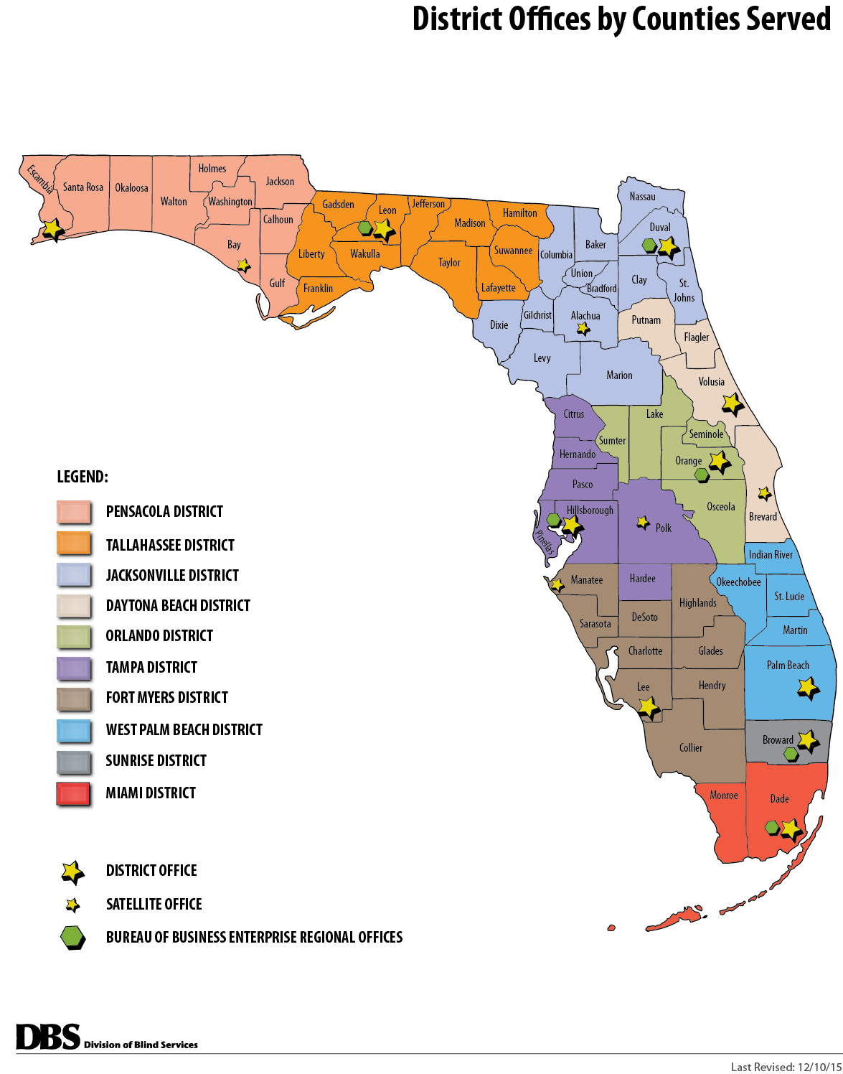

DBS District Offices

During the 2017-2018 FFY, the FRCB held four meetings: Lakeland, Fort Lauderdale, West Palm Beach and Orlando. At each quarterly meeting, a public forum was held to receive consumer input on the effectiveness of services provided by DBS.

Agenda Items

Quarterly Meetings and Public Forums

- Welcome, Introductions and Pledge of Allegiance
- Adoption of Agenda
- Director’s Report: Division of Blind Services Updates
- District Administrator’s Report
- Employer Recognition
- Local Community Rehabilitation Program Reports
- Client Satisfaction Survey Data Updates
- Division of Blind Services State Plan Updates
- Vocational Rehabilitation Goals Updates
- New Committee Appointments
- Bureau of Business Enterprise Update
- Workforce Innovation and Opportunity Act of 2014
- FDBS Budget Report and Legislative Updates
- Blind Services Foundation Update
- Updates on Outreach to Underserved/Unserved
- Strategic Plan Discussions

2017-2018 Meeting Dates and Locations

October 26-27, 2017 - Lakeland
February 5- 7, 2018 – Fort Lauderdale
May 2-4, 2018 –West Palm Beach
July 25-27, 2018 –Orlando

Employer Recognition
The Florida Rehabilitation Council for the Blind and the Division of Blind Services annually offers their gratitude to local businesses and employers who support FDBS by hiring and showing support towards individuals who are blind or visually impaired by creating a barrier free environment allowing them to obtain their independence.

The FRCB and FDBS presented the Appreciation Awards at each quarterly business meeting. For FFY 2017-2018, the following employers were recognized:

Winter Haven Hospital

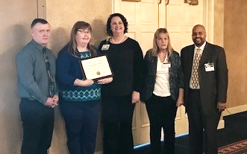

Popeye’s Louisiana Kitchen, Inc.

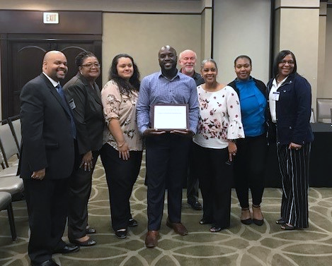

Care Assist Home Care Inc.

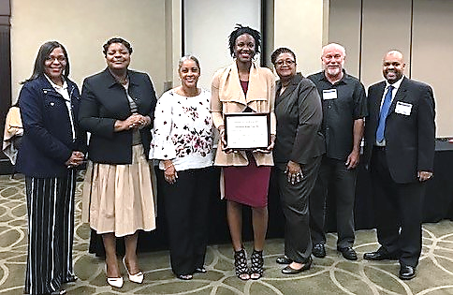

Outback – Kirkman Road / Outback Florida Mall
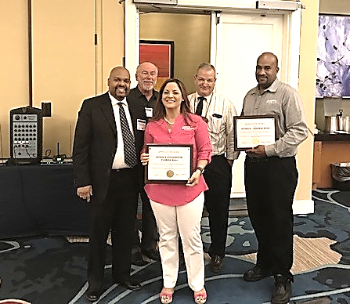
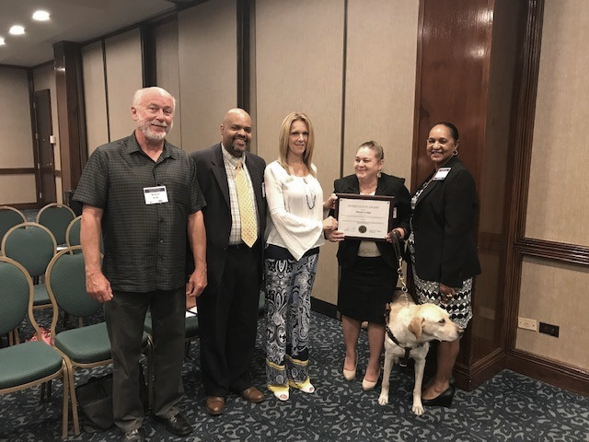

Stuart Lodge

Expenses
Expense | Oct-17 | Nov-17 | Dec-17 | Jan-18 | Feb-18 | Mar-18 | Apr-18 | May-18 | Jun-18 | Jul-18 | Aug-18 | Sep-18 | Total
Council Travel | 3,268.70 |  |  |  | 6,090.42 |  | 1,154.10 | 3,934.49 |  | 4,865.67 |  |  | $19,313.38
Client Satisfaction Survey |  |  |  |  |  |  | 13,250.00 |  | 12,750.00 |  |  |  | $26,000.00
Advertising | 27.86 | 24.78 | 0.00 | 0.00 | 92.68 | 24.08 | 26.46 | 111.44 | 27.02 | 0.00 | 76.58 | 25.62 | $ 436.52
Venue Meeting Space | 900.00 |  |  |  | 1,220.00 |  |  | 1,464.00 |  | 1,875.00 |  |  | $ 5,459.00
Supplies | 81.60 |  |  | 70.20 |  |  |  |  |  |  | 119.11 |  | $ 270.91
Total | 4,278.16 | 24.78 | 0.00 | 70.20 | 7,403.10 | 24.08 | 14,430.56 | 5,518.93 | 12,777.02 | 6,740.67 | 195.69 | 25.62 | $51,479.81

Beginning in 2004, the Florida Rehabilitation Council for the Blind decided to collect customer satisfaction data on a more “real time” basis. Rather than conduct one survey that included all of the clients who had their cases closed the preceding year, the Council decided to have the data collected on a monthly basis and review the results at their quarterly meetings. This report summarizes the data collected for the 2017-18 state fiscal year, which includes cases closed between July 1, 2017 and June 30, 2018. The Customer Satisfaction Survey of former Division of Blind Services (DBS) clients gathers perspectives of former DBS clients concerning program services, levels of satisfaction, and areas for program improvement. This report describes the methods used and presents the 2017-2018 results for clients with cases closed between July 1, 2017 and June 30, 2018. In the fall of 2009, the Florida Rehabilitation Council for the Blind modified the previous survey to streamline the interviews and update information in new areas. Some minor modifications to this survey were made October 2010. Many of the items remained comparable or identical to the survey administered the previous 7 years. In these instances, data for the 10 previous years are provided for comparison purposes. For new questions, major modifications made to question wording, or questions asked of different populations (new screens), no comparisons to prior years can be made. In 2015, the fiscal year changed from the months of April through March to the months of July through June. Data for the years of 2014, 2015, 2016 and the current year are based on the new schedule.

Customer Satisfaction Survey (2017-2018)
Beginning in July of 2017, the Florida Rehabilitation Council for the Blind has included questions regarding local service providers in addition to DBS.
Survey Procedures
Population Surveyed. The Florida State University Survey Foundry (FSUSF), Institute of Science and Public Affairs, conducted a telephone survey of former Division of Blind Services (DBS) clients on a monthly basis. Employment-bound clients with cases “closed” between July 1, 2017 and June 30, 2018 comprises the population surveyed for this year-end report.

DBS provided the names, addresses, phone numbers and demographic information for 881 former clients. Among them, one client that did not have a phone number on record. Case closures are classified into two major groupings, those with successful and unsuccessful closures. Among successful closure group, we include clients whose case status are post closure.

Overall Satisfaction

Client Satisfaction with the DBS program is high. To gauge the overall level of satisfaction with the DBS program, former clients were asked if they would recommend DBS services to others. During 2017-18, 94 percent (181 of 201), said, “Yes”, they would recommend DBS services to others. Clients were also asked to rate their overall satisfaction with the program. During 2017-18, 84 percent of the clients (165 of 196) were either “Satisfied” or “Very Satisfied with the program.

Beginning in 2017, former clients were also asked to evaluate their local service providers separately from DBS. During 2017-2018, 92% would recommend their local service provider. When clients were asked to rate their overall satisfaction of their local service provider, 94% were satisfied.

For a complete copy of the Customer Satisfaction Survey of Division of Blind Services Clients survey results for SFY 2017-2018, please visit our website at the link below.

Florida Division of Blind Services Website

Florida DBS VR Performance Based Budget Measures

Outcomes

DBS VR Performance Based Data | FFY2014 | FFY2015 | FFY2016 | FFY 2017 | FFY2018
Number of Customers Served | 5357 | 5282 | 5333 | 5039 | 5031
Number of Customers Successfully Closed | 721 | 771 | 813 | 851 | 856

Consumers Earnings Data –Federal Fiscal Year

 | FFY2014 | FFY2015 | FFY2016 | FFY 2017 | FFY2018
Average # of Hours worked per week | 29.64 | 28.98 | 27.76 | 28.94 | 29.96
Average Hourly Wage | 13.54 | 13.96 | 12.98 | 13.85 | 14.61
Average Weekly Wage | $399.85 | $403.56 | $384.61 | $405.21 | $441.62
Projected Average Annual Earnings at Placement | $20,792.15 | $20,984.93 | $19,999.86 | $21,070.72 | $22,964.30
Average Case Cost | $6,931.53 | $7,982.29 | $8,288.05 | $9,625.00, | $9,215.26

Committees

Executive Committee

Robert Kelly, Chair
Mikey Wiseman, First Vice Chair
Paul Edwards, Second Vice Chair

Planning Committee

Paul Edwards, Chair
Buce Miles
Robert Kelly
Howard Bell
Paul Kurtz
Denise Valkema

Evaluation Committee

Bruce Miles, Chair
Patricia Lipovsky
Howard Bell
Paul Edwards
Michael Wiseman
Nicole Attong
Louise Peyton

How to become a FRCB Member
The governor appoints the members of the council in accordance with Section 105 of the Rehab Act and Chapter 413.011, Florida Statutes. Appointments are for three-year terms. A majority of the council shall be persons who are: (1) blind, and (2) not employed by the division.

The Gubernatorial Appointments Questionnaire can be found at Governor's Appointment Website
Questions regarding the Council or the application process may be directed to:
Florida Rehabilitation Council f/t Blind
Florida Division of Blind Services
325 West Gaines Street
Tallahassee, Florida 32399
Telephone :( 850) 245-0329
Fax: (850) 245-0363
Office of Governor Rick Scott
Appointments Office
Telephone (850) 717-9243
Fax: (850) 921-0733

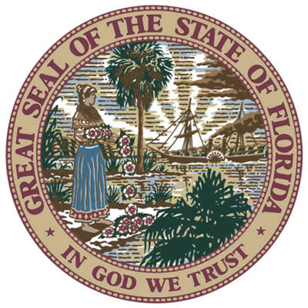
For More Information, Please Contact:
Selena Sicker
Staff Assistant, Florida Rehabilitation for the Blind
Division of Blind Services
325 West Gaines Street
Tallahassee, Florida 32399
Selena.Sickler@dbs.fldoe.org
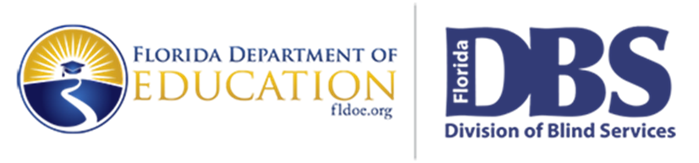
www.dbs.myflorida.dbs.fldoe.org

